|  |
| --- |
| Close-up image showing the leaf-sides of two oversized books side-by-side on a bookshelf, with additional books in soft focus background |
| Data mining  Customer segmentation and claim prediction: Project report |
| |  |  |  | | --- | --- | --- | | Aditya Rishi | 6/27/21 | Great Learning | |

Machine Learning as problem solver for the businesses

**Charts** 

Tab 1: The bank's credit card marketing dataset

ab 2: Data summary

Tab 3: Data info

Tab 4: Five-number summaries for each variable

Tab 5: Scaled dataset

Tab 6: Silhouette score list

Tab 7: Data sets with clusters added

Tab 8: Data set with clusters and frequency added

Tab 10: Data summary for cluster 1

Tab 11: Data summary for cluster 2

Tab 12: Dataset with appended 3 clusters

Tab 13: Dataset pivoted on three clusters, with appended frequencies

Tab 13,14,15,16: Dataset with pivoted on 3 agglomerative clusters, with mean, sum, maximum, and minimum variations.

Tab 14: K-means 2 and K-means 3 cluster size comparison.

Tab 15: Dataset with appended K-means 3 cluster

Tab 16: Dataset pivoted on K-means 3 clusters and with appended frequencies.

Tab 17: Dataset with appended silhouette width

Tab 18: Data summary for high spenders

Tab 19: Data summary for low spenders

Tab 20: Data summary of medium spenders

Fig 1: Boxplots for all variables

Fig 2: Boxplots after outlier removal

Fig 3: Kernel Density Estimate plots for all variables

Fig 4: Frequency of variables

Fig 5: KDE plot for spending

Fig 6: Multivariate density plot

Fig7: Heatmap to check correlations

Fig 8: Pairplot

Fig 9: Hued pairplot for current balance

Fig 10: Hued pairplot for spending

Fig 11: Hued pairplot for maximum spend in single shopping

Fig 12: Hued pairplot for advance payment

Fig 13: Hued pairplot for credit limit

Fig 13: Hued pairplot for probability of full payment

Fig 14: Boxplot of scaled dataset

Fig 15: First dendrogram

Fig 16: Big dendrogram

Fig 17: Truncated dendrogram

Fig 18: Dendrogram 1

Fig 19: Dendrogram 2

Fig 18.1: Line plot for the elbow method. WSS for 10 values of K are plotted on it.

Fig 19.1: Double elbow marked in red.

Fig 20: Variable histograms for each cluster

Fig 21: Scatterplot of credit limit and advance payments, hued on K-means 3 clusters

Fig 22: Pairplot hued on KM3 clusters. Quite differnt from the previous hued pairplots.

Fig 23: Scatter plots of different variables against advance payment.

Fig 24: Spending against advance payments and current balance.

Fig 24: Spending against credit limit and minimum payment amount.

Fig 26: Spending against probability of full payment and maximum spent in single shopping.

Fig 27: Advance payments against probability of full payment and current balance

Fig 28: Advance payments payments against credit limit and maximum spent in single shopping.

Fig 29: Probability of full payment against current balance and credit limit

Fig 30: Current balance against credit limit and minimum payment amount.

Fig 31: Credit limit against minimum payment amount and maximum spent in single shopping.

Fig 32: Minimum payment amount against maximum spent in single shopping and spending.

Fig 33,34,35,36: 3-D views of K-means 3 clusters

**Tables **

I N D E X

# 

**Problem 1: Clustering**

**Executive summary**

A leading bank wants to develop a customer segmentation to give promotional offers to its customers. They collected a sample that summarizes the activities of users during the past few months. You are given the task to identify the segments based on credit card usage.

**Introduction**

A market segmentation strategy, a way of pushing products and services, is important to banks and financial institutions, and is of two fundamental kinds: They can try to sell to everyone (mass-marketing) or focus their efforts on target segments (segmentation-marketing).

In most cases, mass-marketing is expensive and ineffective. For this reason, a market segmentation study should be a key component in any company's overall strategic plan.

Typically, banks tend to acquire new customers at huge costs rather than leveraging their existing customer base. A bank’s customers leave behind a large footprint in terms of the transactions they perform, which can be analyzed to understand their behavior pattern which may be leveraged for selling new products. Segmentation models based on elementary classification schemes use ‘spending’ as the main demographic variable to cluster or segment their customer base.

Consumer banking preferences and behaviors continue to change based on technological advances, demographics and social factors. Retail bank executives seek to drive revenue generation by growing share of wallet from existing customer relationships. While customer acquisition is still important, greater emphasis is being placed on targeting current customer segments more accurately. The goal is to identify and capitalize on opportunities for revenue growth through cross selling and up selling. Meeting this priority requires a deep understanding of what customers need, want, expect and value in a financial institution.

**A short story about segmentation**

A client bank engaged BSG consultants to assess its private bank, which was underperforming. BSG worked closely with the bank’s marketing group to analyze its customer base against criteria for wealth management and private banking segments. The analysis determined that the bank was over-penetrated in the mass affluent segment, but did not have a scheme in place to properly serve this segment. While the bank had a well-developed overall segmentation scheme, it was not designed to be used for managing the credit card business. BSG’s wealth management experts assisted in developing and implementing a more effective mass market service platform.

**Card trick: For the customers**

Once you consent your willingness to be part of customer categorization, you will always be part of one or the other customer category depending upon your relationship value to be assessed on a half yearly basis. You will be upgraded or downgraded to other categories automatically based on whether your relationship value with the bank increases or decreases. It will be assessed on a yearly basis. You will earn benefits based on your eligible category during any period. You will be communicated through SMS, e-mail or registered number when these are upgraded or downgraded.

**About clustering methods:  
K-means, a mean formula**

Hierarchical clustering and k-means method can help customer segmentation plans a great deal. The k-means algorithm is an algorithm used commonly for clustering points. While this algorithm works quite well in practice, there are two aspects of this algorithm that are hard to grasp theoretically. First, it has been hard to prove any meaningful upper bound on the running time of this algorithm. In practice, k-means takes a sublinear number of iterations to converge for real datasets.

Smoothed analysis has given polynomial-time bounds to this problem, but even these bounds are much higher than what has been observed empirically. Secondly, it has been hard to quantify the accuracy of the solution that k-means converges to. Although k-means has guaranteed convergence because each step of the algorithm performs coordinate descent on the k-means objective, the algorithm rarely converges to the exact optimal solution because it mostly gets stuck at local minima. We were interested to see if the performance of k-means correlated with notions of stability we had discussed in class. Against our predictions, k-means did well through all the data. As an experiment beyond the scope of this project, we even pitted it against density-based DBSCAN and other clustering algorithms, and the little k-means 3 model beat them all. We'll mention that in brief, later. As far as time efficiency goes, k-means was far superior, even in the worst case. Since our dataset for it was not so large, even if k-means was run 25 different times, it would still be superior in time efficiency.

**Data dictionary for  
market segmentation:**

**1. spending:** Amount spent by the customer per month (in 1000s)

**2. advance_payments:** Amount paid by the customer in advance by cash (in 100s)

**3. probability_of_full_payment:** Probability of payment done in full by the customer to the bank

**4. current_balance:** Balance amount left in the account to make purchases (in 1000s)

**5. credit_limit:** Limit of the amount in credit card (10000s)

**6. min_payment_amt :** minimum paid by the customer while making payments for purchases made monthly (in 100s)

**7. max_spent_in_single_shopping:** Maximum amount spent in one purchase (in 1000s)

**1.1 Read the data and do exploratory data analysis. Describe the data briefly.**

The dataset loaded correctly and has 210 rows and 7 columns or variables and these seem to be all numeric.

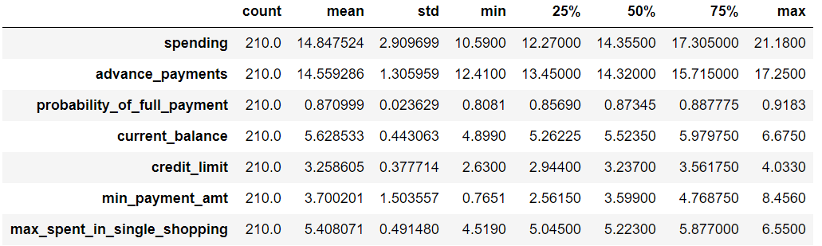

Tab 2: Data summary

There's not a major difference #between the 75th percentile and the maximum value for all the variables. Nevertheless, we will check for outliers by making box plots.

**# Are there any missing values?**

spending 0  
advance_payments 0  
probability_of_full_payment 0  
current_balance 0  
credit_limit 0  
min_payment_amt 0  
max_spent_in_single_shopping 0  
dtype: int64

**There are no missing values**

# Data types

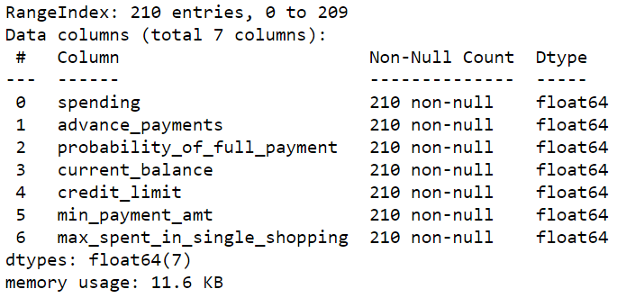

Tab 3: Data info

All the seven variables are numeric, of data type float. This meets the basic requirement for the clustering algorithms that we'd like use for customer segmentation.

**Are there any duplicates?**

Number of duplicate rows = 0

There are no duplicates or missing values.

Second look after outlier treatment.

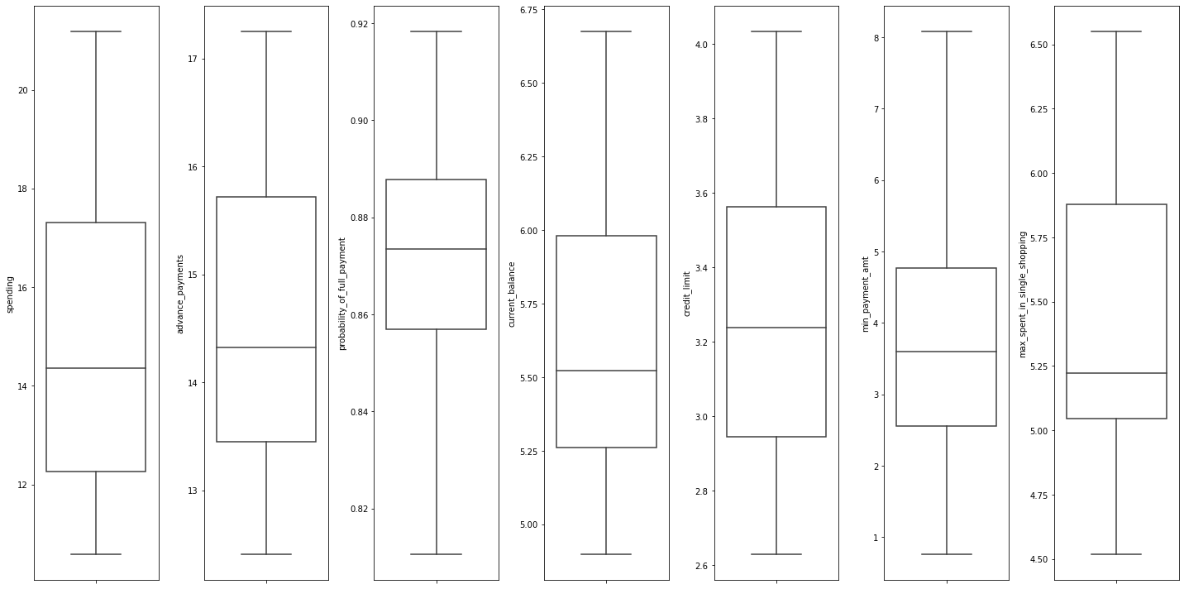

Fig 2: Boxplots after outlier removal

For clustering, only the numeric columns are used. The outliers are points that do not meet distance and minimum samples requirements to be recognised as a cluster The dataset has a very small number of outliers, which we can replace with the upper or the lower limit.

**Further numeric EDA**

**#Frequency variables in charts.**

Fig 4: Frequency of variables

We start by looking at the horizontal or x-axis of these histograms to see how the data in each variable is grouped. Then, we look at the vertical or y-axis to see how frequently that data occurs.

Bar charts and histograms are similar but with some very specific differences. A bar chart groups numbers into categories, while histograms group numbers into ranges.

**Histogram analysis**

Histograms are used to show the results of continuous data, generally. The spending range of up to 12k (rupees/dollars, or anything) has the highest number of customers (32+34=66). The highest number of customers for any advance payment range is 38 for between 13k and 14k. There's nearabout 88% probability of full payment for 78 customers (39+39), which is the highest. 82 customers have a current balance between 5.1k and 5.4k. The credit limit is most uniform across ranges, except when it touches 40k. Understandable, as higher credit limit is only for a few. 37 customers (the most for any range) have minimum payment amount around 3. 100 customers (the most for any range) have spent between 5 and 5.3 on their biggest single shopping trips. Maybe they charged higher-value products on credit card for which cash payment isn't the preferred mode of transaction.

**A look at spending**

Spending density is the maximum for 10 to 15 cost range and is now. The wave picks up around 7 and dies out after touching the shores of 23. A kernel density estimate (KDE) plot is a method for visualizing the distribution of observations in a dataset. This is analogous to a histogram. KDE represents the data using a continuous probability density curve in one or more dimensions. It depicts the probability density at different values in a continuous variable. The density curve for spending in this case has two distinct peaks, indicating that the distribution is bimodal.

**Multivariate density plot.**

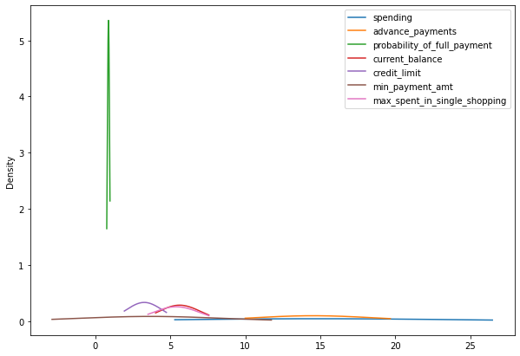

Fig 6: Multivariate density plot

The KDE algorithm takes a parameter, bandwidth, that affects how “smooth” the resulting curve is.

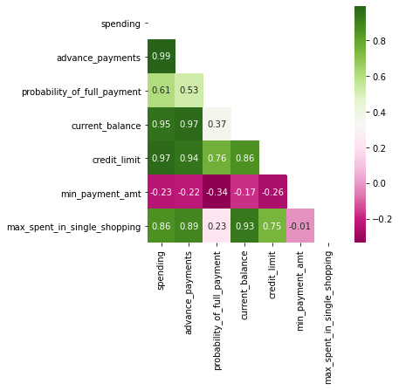

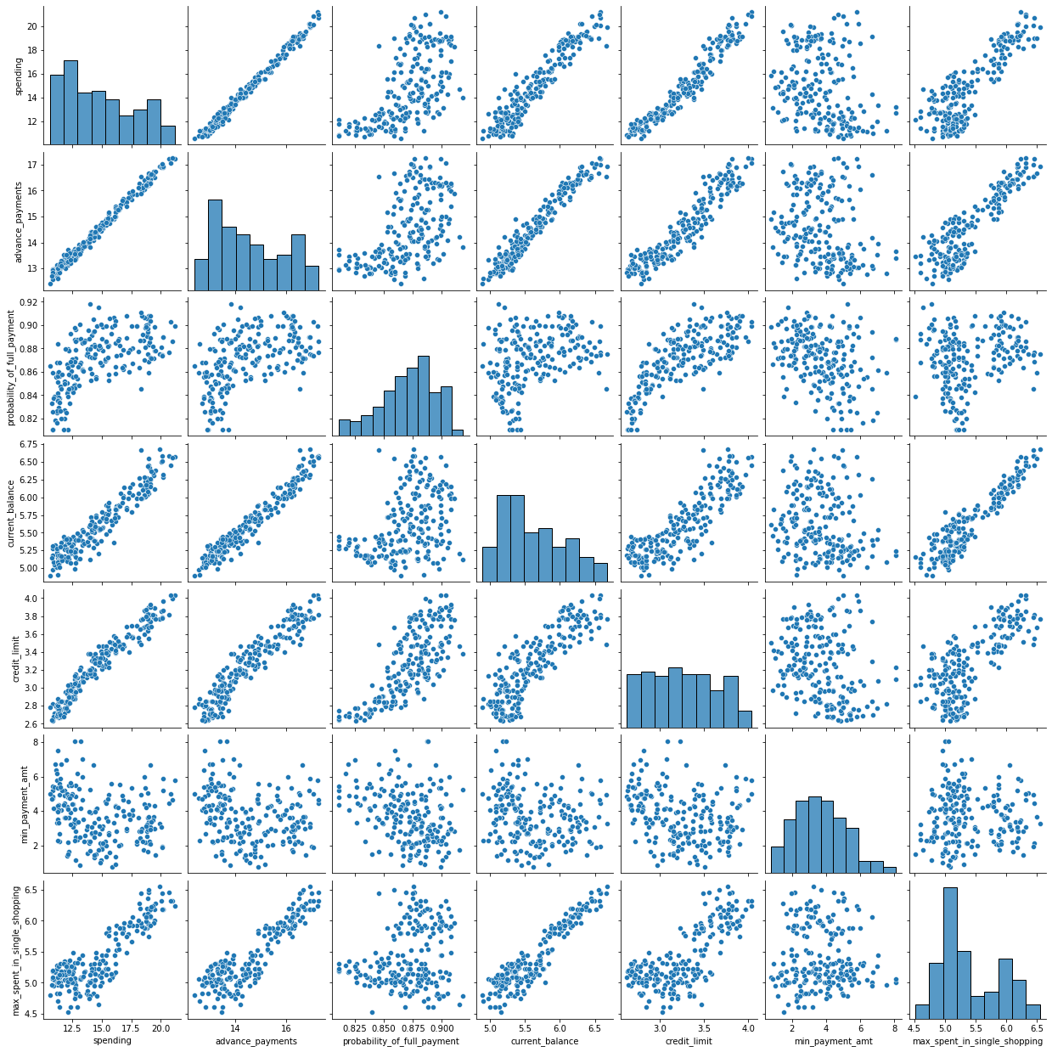

**Variable description**

Description of spending

---------------------------------------

count 210.000000

mean 14.847524

std 2.909699

min 10.590000

25% 12.270000

50% 14.355000

75% 17.305000

max 21.180000

Name: spending, dtype: float64

Description of advance_payments

----------------------------------------------------------------------------

count 210.000000

mean 14.559286

std 1.305959

min 12.410000

25% 13.450000

50% 14.320000

75% 15.715000

max 17.250000

Name: advance_payments, dtype: float64

Description of  
probability_of_full_payment

----------------------------------------------------------------------------

count 210.000000

mean 0.871025

std 0.023560

min 0.810588

25% 0.856900

50% 0.873450

75% 0.887775

max 0.918300

Name: probability_of_full_payment,  
dtype: float64

Description of current_balance

---------------------------------

count 210.000000

mean 5.628533

std 0.443063

min 4.899000

25% 5.262250

50% 5.523500

75% 5.979750

max 6.675000

Name: current_balance,  
dtype: float64

Description of credit_limit

---------------------------------

count 210.000000

mean 3.258605

std 0.377714

min 2.630000

25% 2.944000

50% 3.237000

75% 3.561750

max 4.033000

Name: credit_limit,

dtype: float64

Description of min_payment_amt

---------------------------------

count 210.000000

mean 3.697288

std 1.494689

min 0.765100

25% 2.561500

50% 3.599000

75% 4.768750

max 8.079625

Name: min_payment_amt,  
dtype: float64

Description of  
max_spent_in_single_shopping

---------------------------------

count 210.000000

mean 5.408071

std 0.491480

min 4.519000

25% 5.045000

50% 5.223000

75% 5.877000

max 6.550000

Name:  
max_spent_in_single_shopping,  
dtype: float64

**1.2 Do you think scaling is necessary for clustering in this case? Justify.**

We do have to use scaling, since hierarichal clustering and Kmeans both use distance-based algorithms for computation. Moreover, the data also has a few variables on different scales. For example, probability of full payment is on a scale of  
10^(-4), while spending is on a hundredth scale. Therefore, it become necessary to scale the data. We used z-scaling, because the variance between the columns is more or less the same.

**Checking for outliers again**

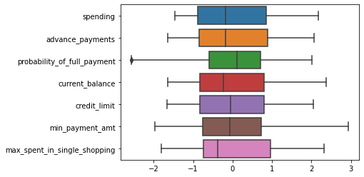

Fig 14: Boxplot of scaled dataset

Negligible outliers

**1.3 Apply hierarchical clustering to scaled data. Identify the number of optimum clusters using Dendrogram and briefly describe them.**

**Hierarchical Clustering**

Get the count of unique values for data

spending 193  
advance_payments 170  
probability_of_full_payment 184  
current_balance 188  
credit_limit 184  
min_payment_amt 206  
max_spent_in_single_shopping 148

dtype: int64

**Creating a dendrogram**

Choosing a clustering method

We make a silhouette score list in order to find an appropriate linkage method out of 'ward, 'average', and 'complete' for hierarchical clustering

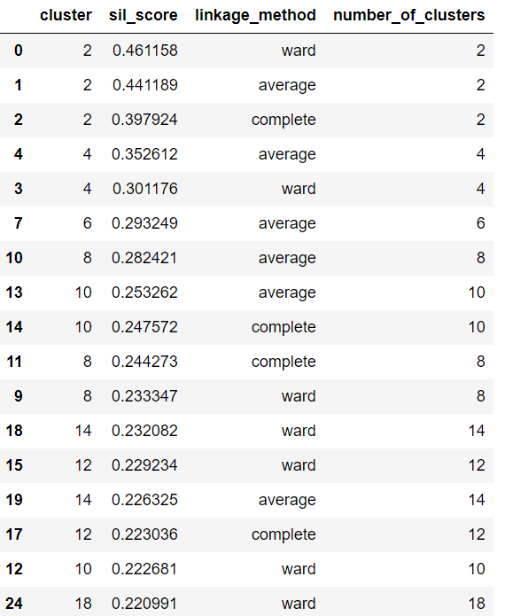

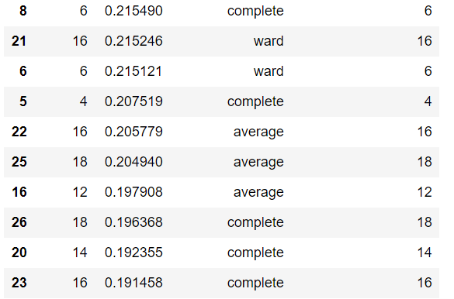

Tab 6: Silhouette score list

We choose the ward method on the basis of the highest silhouette score of 0.461158. Typically, mean silhouette over 0.6 is considered a "good" clustering solution but, for now, this 0.46 is our best option.

# Checking columns

Index(['spending', 'advance_payments', 'probability_of_full_payment', 'current_balance', 'credit_limit', 'min_payment_amt', 'max_spent_in_single_shopping'], dtype='object')

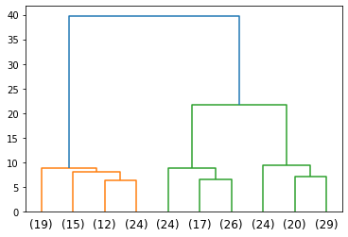

Fig 17: Truncated dendrogram

**Where to cut this dendrogram?** There is no one answer to this. The dendrogram suggests an optimal number (2) based on the colors that it assigns to clusters. At the same time, based on the distance criteria, we can form a different impression on what's optimal. Looking at different metrics and using the knowledge of the data and the clusters, we must make sure that the clusters are heterogeneous or diverse. That way we can optimize the same. If we lower the distance bar, it will cut three lines instead for two, and three might then be the optimal number of clusters. We'll do one thing: make both 2-cluster and 3-cluster models and then choose one that is less costly to the business and more heterogeneous.

**Using fcluster module to create clusters**

Set criterion as distance, then create 2 clusters, and then store the result in another object called 'clusters'.

Method= wardlink  
Criterion=distance  
Distance=25

**Clusters**

array([1, 2, 1, 2, 1, 2, 2, 2, 1, 2, 1, 2, 2, 1, 2, 2, 2, 2, 2, 2, 2, 2,

1, 2, 2, 1, 2, 2, 2, 2, 2, 2, 2, 2, 2, 2, 2, 2, 2, 1, 1, 2, 1, 1,

2, 2, 2, 1, 1, 1, 2, 1, 1, 1, 1, 1, 2, 2, 2, 1, 2, 2, 2, 2, 2, 1,

1, 2, 1, 2, 2, 2, 1, 1, 2, 1, 2, 2, 1, 2, 2, 2, 2, 1, 2, 2, 2, 1,

1, 2, 2, 1, 2, 2, 2, 1, 1, 1, 2, 1, 2, 1, 2, 1, 2, 1, 1, 2, 2, 1,

2, 2, 1, 2, 2, 1, 2, 2, 2, 1, 2, 2, 2, 2, 2, 2, 1, 2, 2, 2, 2, 2,

2, 1, 2, 1, 1, 2, 1, 2, 2, 2, 2, 2, 2, 2, 1, 2, 2, 2, 2, 2, 2, 2,

2, 2, 2, 2, 2, 1, 1, 2, 1, 1, 1, 2, 1, 2, 2, 2, 2, 2, 2, 1, 1, 1,

2, 2, 1, 2, 2, 2, 2, 2, 1, 1, 2, 2, 2, 2, 2, 2, 2, 1, 2, 1, 1, 2,

1, 2, 2, 1, 2, 2, 1, 2, 1, 2, 1, 2], dtype=int32)

**Cluster frequency**

1 70  
2 140

Cluster 1 has 70 records, while cluster 2 has 140 out of 210.

**Using Agglomerative Clustering**

Affinity=Euclidean  
Linkage=Ward

**Clusters**

[1 0 1 0 1 0 0 0 1 0 1 0 0 1 0 0 0 0 0 0 0 0 1 0 0 0 0 0 0 0 0 0 0 0 0 0 0

0 0 1 1 0 1 1 0 0 0 1 1 1 0 1 1 1 1 1 0 0 0 1 0 0 0 0 0 1 1 0 1 0 0 0 1 1

0 1 0 0 1 0 0 0 0 1 0 0 0 0 1 0 0 1 0 0 0 1 1 1 0 1 0 1 0 1 0 1 1 0 0 1 0

0 1 0 0 1 0 0 0 1 0 0 0 0 0 0 1 0 0 0 0 0 0 1 0 1 1 0 1 0 0 0 0 0 0 0 1 0

0 0 0 0 0 0 0 0 0 0 0 1 1 0 1 1 1 0 0 0 0 0 0 0 0 1 1 1 0 0 0 0 0 0 0 0 0

1 0 0 0 0 0 0 0 1 0 1 1 0 1 0 0 0 0 0 1 0 1 0 0 0]

**# Columns**

Index(['spending',   
advance_payments',   
probability_of_full_payment', 'current_balance', 'credit_limit', 'min_payment_amt', 'max_spent_in_single_shopping', 'clusters', 'Agglo_CLusters'], dtype='object')

**Recommendations**

**Outcomes**

**1.** Like said before, customers from cluster 1 are better at advance payments than those in cluster 2.

**2.** Examination of the mean and standard deviation shows that the customers in cluster 1 have a higher spending habit than those in cluster 2.

**3.** Cluster 1 spends more in single shopping, yet both clusters have only a marginal difference in credit limit.

**4.** Their probabilities of making full payment are almost the same.

**Suggestions**

**1.** Since customers in cluster 2 lag in advance payment, the bank can introduce schemes such as doubling the reward points of whoever pays in advance.

**2.** To increase the minimum payment amount, the bank can introduce some cashback offers of up to a certain amount's worth of minimum purchase.

**3.** Since the customers in cluster 1 have a better record, the bank can consider them its premium clients and think of introducing cashback offers for them to encourage more on spending.

**4.** It'll be fair and good to increase the credit limit of premium clients to separate them from normal customers. Also, because there is a strong correlation between spending and credit limit. We can increase the credit limit for both category of customer segments, while giving the higher spenders a lot more freedom.

We saved cluster profiles in a csv file and made these Excel graphics based on its output.

**# Checking out the  
3-cluster model**

Method=wardlink  
Criterion='distance  
Distance=20

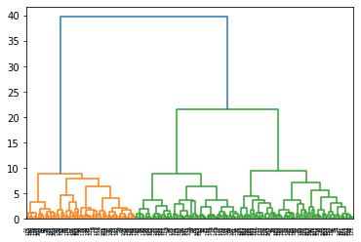

Fig 18: Dendrogram  
  


Fig 19: Truncated dendrogram

**Clusters**

array([1, 3, 1, 2, 1, 2, 2, 3, 1, 2, 1, 3, 2, 1, 3, 2, 3, 2, 3, 2, 2, 2,

1, 2, 3, 1, 3, 2, 2, 2, 3, 2, 2, 3, 2, 2, 2, 2, 2, 1, 1, 3, 1, 1,

2, 2, 3, 1, 1, 1, 2, 1, 1, 1, 1, 1, 2, 2, 2, 1, 3, 2, 2, 3, 3, 1,

1, 3, 1, 2, 3, 2, 1, 1, 2, 1, 3, 2, 1, 3, 3, 3, 3, 1, 2, 3, 3, 1,

1, 2, 3, 1, 3, 2, 2, 1, 1, 1, 2, 1, 2, 1, 3, 1, 3, 1, 1, 2, 2, 1,

3, 3, 1, 2, 2, 1, 3, 3, 2, 1, 3, 2, 2, 2, 3, 3, 1, 2, 3, 3, 2, 3,

3, 1, 2, 1, 1, 2, 1, 3, 3, 3, 2, 2, 3, 2, 1, 2, 3, 2, 3, 2, 3, 3,

3, 3, 3, 2, 3, 1, 1, 2, 1, 1, 1, 2, 1, 3, 3, 3, 3, 2, 3, 1, 1, 1,

3, 3, 1, 2, 3, 3, 3, 3, 1, 1, 3, 3, 3, 2, 3, 3, 2, 1, 3, 1, 1, 2,

1, 2, 3, 1, 3, 2, 1, 3, 1, 3, 1, 3], dtype=int32)

Cluster size

1 70

2 67

3 73

Cluster profile

Tab 13: Dataset pivoted on three clusters, with appended frequencies

Cluster 1: High spenders with high advance payments

Cluster 2: Low spenders with high minimum payment amount and low credit limit

Cluster 3: Medium spenders with advance payment level 14 and least minimum payment amount of all three segments

# Using Agglomerative Clustering

Clusters=3

Affinity=Euclidean

Linkage=Ward

Agglomerative clusters

[0 1 0 2 0 2 2 1 0 2 0 1 2 0 1 2 1 2 1 2 2 2 0 2 1 0 1 2 2 2 1 2 2 1 2 2 2

2 2 0 0 1 0 0 2 2 1 0 0 0 2 0 0 0 0 0 2 2 2 0 1 2 2 1 1 0 0 1 0 2 1 2 0 0

2 0 1 2 0 1 1 1 1 0 2 1 1 0 0 2 2 0 1 2 2 0 0 0 2 0 2 0 1 0 1 0 0 2 2 0 1

1 0 2 2 0 1 2 2 0 1 2 2 2 1 1 0 2 1 1 2 1 1 0 2 0 0 2 0 1 1 1 2 2 1 2 0 2

1 2 1 2 1 1 1 1 1 2 1 0 0 2 0 0 0 2 0 1 1 1 1 2 1 0 0 0 1 1 0 2 1 1 1 1 0

0 1 1 1 2 1 1 2 0 1 0 0 2 0 2 1 0 1 2 0 1 0 1 0 1]

Tab 13,14,15,16: Dataset with pivoted on 3 agglomerative clusters, with mean, sum, maximum, and minimum variations.

The output was saved to file and Excel graphs were made for the inference.

# Recommendations

1. Beyond what has been proposed for the two categories before, here's something more we propose:-

2. Colour scheme: Using a simple colour scheme, the bank can introduce the gold, silver, and platinum cards for the three classes of customers, with a varying degree of benefits and special privileges such as extra points. Add higher limits, fees, reward points, and cache to higher cards.

3. Loans: These cards can come with pre-approved loans (for housing, car, education, and retail), say silver for Rs 25 lakh, gold for Rs 25 lakh to Rs 50 lakh, and platinum for Rs 50 lakh to Rs 1 crore.

4. Rating: The bank can start card-based credit rating to encourage more full payments.

5. Show time: Run a scheme that allows card holders access to coveted show tickets before they are available to the general public. That'll encourage more spending across categories.

6. Link it to cash: The platinum card, which, in addition to quadrupling the gold card fees, could offer cash availability anywhere around the world without the need for a cheque, besides hotel upgrades when available and other travel and concierge services.

7. Top class: Create a high-quality magazine aimed solely at the top segment (which will also make big money on the advertising on account of being desired by high-end vendors as one of the very few magazines targeted fully to their target audience. The vendors will minimize wasted advertising.

8. Let's play: Offers exclusive performances and evenings with different artists, authors, actors etc. Top spenders should get IPL, Euro Cup, World Cup box tickets for sense of exclusivity and greater following.

9. Boss card: Introduce high-end credit card differentiation. Beyond silver, gold, or platinum, call it "the Boss card" or something, so exclusive you shouldn't be able to apply for it. It's a "by invitation only" product, and the invitations are extended only to the most credit-worthy customers, who spend at least a certain high amount of money using their card annually. Put a price on it and the card should be hand delivered in a designer box. Exclusive customers seek exclusive items and experiences.

10. Reward: Reward the customers for the length and size of business. This will encourage them to stay with the bank, which will save it the cost of acquiring new customers. Instead of validity date, the cards could say: "Member since".

11. Use digital age: Allow customers to transfer money via smartphone using their card number at any time using. This will encourage more middle spenders towards cashless transaction.

12. A card they can bank on: To attract low spenders towards using their credit card more often or exploring more of its applications, add traditional banking features such as account opening, money transfer, bill payment, and retail transactions, since this class has to queue up for most of these services, otherwise. The bank can also link it with subsidies.

13. Hacker-proof: For high spenders at least, replace magnectic strip on the card with biometric authentication to make their accounts and transactions safer, as they will use biometric scans in place of PIN or password. Remember, their accounts are bank's cash cow.

# Suggested model out of the two

Go with 3 clusters

Since cluster analysis is essentially an exploratory approach, the interpretation of the resulting hierarchical structure is context-dependent and often several solutions are equally good from a theoretical point of view.

Even though cheaper, a generic credit card scheme tailored to the average will have the lowest response rate. A scheme that is tailored to each individual will have the highest cost. Three schemes tailored to three segments will be somewhere in between. This is the revenue side.

The silhouette score is best for 2 clusters but it's still far below 0.6. The score is only 0.46 or so, so, one the clusters are not all that well separated, and two, the chances of calling it right are less than 50%.

To maximize profit, the bank would want to keep segmenting until the marginal revenue from segmenting equals the marginal cost of segmenting. In this case study, our suggestion to the bank is to use three segments to maximize profit. The cost of losing a customer segment can be huge.

1.4 Apply K-Means clustering on scaled data and determine optimum clusters. Apply elbow curve and silhouette score.

KMeans

In order to find an appropriate number of clusters, the elbow method will be used.

In this method for this case, the inertia for a number of clusters between 2 and 10 will be calculated.

The rule is to choose the number of clusters where you see a kink or "an elbow" in the graph.

Calculating Within Cluster Sum of Squares or WSS for 10 values of K

[1469.999999999999,

659.14740095485,

430.298481751223,

370.6909292210199,

327.8379162768708,

294.70740950686735,

262.5742242335426,

240.20718392679387,

222.41512322267613,

205.2353741836641]

Fig 18: Line plot for the elbow method. WSS for 10 values of K are plotted on it.

Fig 19: Double elbow marked in red.

# Kmeans with Different Number of Clusters from 2 to 10

Silhouette scores for different clusters

Silhouette score for 2 cluster k-means: 0.466

Silhouette score for 3 cluster k-means: 0.401

Silhouette score for 4 cluster k-means: 0.335

Silhouette score for 5 cluster k-means: 0.281

Silhouette score for 6 cluster k-means: 0.277

Silhouette score for 7 cluster k-means: 0.276

Silhouette score for 8 cluster k-means: 0.265

Silhouette score for 9 cluster k-means: 0.272

Silhouette score for 10 cluster k-means: 0.260

We have a double elbow, at 2 and 3 clusters, marked with vertical red lines. The other clusters have very little intertia.

Looking into the cluster sizes across both algorithm

Tab 14: K-means 2 and K-means 3 cluster size comparison.

Silhouette score is better for 2 clusters than for 3 clusters. But we should also look at the elbow method. To determine the optimal number of clusters, we have to select the value of k at the “elbow”, i.e. the point after which the distortion/inertia starts decreasing in a linear fashion for the given data. We conclude that the optimal number of clusters for the data is 3. It also seems from the size comparison of the algorithms that KMeans model with 3 clusters has more evenly balanced observations. We'll go with 3 clusters.

KMeans with K=3

Clusters

array([0, 2, 0, 1, 0, 1, 1, 2, 0, 1, 0, 2, 1, 0, 2, 1, 2, 1, 1, 1, 1, 1,

0, 1, 2, 0, 2, 1, 1, 1, 2, 1, 1, 2, 1, 1, 1, 1, 1, 0, 0, 2, 0, 0,

1, 1, 2, 0, 0, 0, 1, 0, 0, 0, 0, 0, 1, 1, 1, 0, 2, 1, 1, 2, 2, 0,

0, 2, 0, 1, 2, 1, 0, 0, 1, 0, 2, 1, 0, 2, 2, 2, 2, 0, 1, 2, 0, 2,

0, 1, 2, 0, 2, 1, 1, 0, 0, 0, 1, 0, 2, 0, 2, 0, 2, 0, 0, 1, 1, 0,

2, 2, 0, 1, 1, 0, 2, 2, 1, 0, 2, 1, 1, 1, 2, 2, 0, 1, 2, 2, 1, 2,

2, 0, 1, 0, 0, 1, 0, 2, 2, 2, 1, 1, 2, 1, 0, 1, 2, 1, 2, 1, 2, 2,

1, 2, 2, 1, 2, 0, 0, 1, 0, 0, 0, 1, 2, 2, 2, 1, 2, 1, 2, 0, 0, 0,

2, 1, 2, 1, 2, 2, 2, 2, 0, 0, 1, 2, 2, 1, 1, 2, 1, 0, 2, 0, 0, 1,

0, 1, 2, 0, 2, 1, 0, 2, 0, 2, 2, 2])

# Appending clusters to the original dataset

Tab 15: Dataset with appended K-means 3 cluster

Output saved in .csv file and graphs made on the basis.

Cluster profiling

0 67

1 72

2 71

Tab 16: Dataset pivoted on K-means 3 clusters and with appended frequencies.

# The three customer segments are similar to the ones detected by hierarchical clustering model. We'll describe those, later.

Model evaluation

Computing silhouette width¶

array([0.5732776 , 0.36556355, 0.63709249, 0.515595 , 0.36097201,

0.22152508, 0.47529542, 0.36025848, 0.51938329, 0.53443903,

0.46599399, 0.12839864, 0.39177784, 0.52379458, 0.11202082,

0.22512083, 0.33760956, 0.5018087 , 0.03635503, 0.23801566,

0.36177434, 0.3693663 , 0.43153403, 0.26364196, 0.47484293,

0.06663956, 0.27151643, 0.50414367, 0.55487254, 0.43479958,

0.37528473, 0.43006502, 0.39151526, 0.3943622 , 0.5362567 ,

0.55717776, 0.50878421, 0.42617776, 0.50641159, 0.62170114,

0.55929539, 0.48579454, 0.39864428, 0.61044051, 0.51398993,

0.37791063, 0.30664315, 0.58154614, 0.48759463, 0.53302467,

0.31693425, 0.49463828, 0.58531649, 0.59861082, 0.61892471,

0.23370264, 0.44475373, 0.54060572, 0.57808265, 0.57623567,

0.55297302, 0.51585343, 0.55579575, 0.27793624, 0.49524145,

0.56405298, 0.57784591, 0.52274801, 0.6313322 , 0.08521853,

0.44260057, 0.3237709 , 0.54096805, 0.5820664 , 0.29582948,

0.58655026, 0.45231288, 0.46830265, 0.36000354, 0.47143411,

0.35317476, 0.28265172, 0.47102324, 0.43236677, 0.54323936,

0.10831225, 0.22108374, 0.00448511, 0.03036773, 0.16534823,

0.20285151, 0.51765323, 0.48590397, 0.46259037, 0.12086046,

0.47867023, 0.52337341, 0.1289478 , 0.5618949 , 0.50054917,

0.07194211, 0.63868093, 0.35554133, 0.58968356, 0.43872323,

0.56951742, 0.44700962, 0.27276241, 0.05068582, 0.57424805,

0.13242666, 0.4626182 , 0.53707541, 0.37068256, 0.51956487,

0.37098379, 0.45441607, 0.01914986, 0.56112586, 0.57214236,

0.09120134, 0.4945929 , 0.31958252, 0.23703607, 0.45224539,

0.47366877, 0.45916664, 0.5837774 , 0.51266421, 0.51798195,

0.53490128, 0.49085079, 0.12532637, 0.54900399, 0.55651719,

0.52279708, 0.46100705, 0.4770828 , 0.2945584 , 0.36502559,

0.20876186, 0.51160405, 0.49320708, 0.36218263, 0.00606357,

0.48178891, 0.50754259, 0.56282114, 0.46576776, 0.50057087,

0.29104633, 0.34205027, 0.54985868, 0.11961635, 0.15510656,

0.4370881 , 0.01156361, 0.58866461, 0.4920353 , 0.50917157,

0.54981126, 0.16832273, 0.49074961, 0.40644768, 0.56222673,

0.53028456, 0.08211016, 0.48792563, 0.28247582, 0.31468493,

0.29983623, 0.55421689, 0.53187089, 0.48192209, 0.54055018,

0.55091698, 0.45775599, 0.04751093, 0.08299646, 0.44235462,

0.48260857, 0.07809599, 0.27491244, 0.40433159, 0.24770267,

0.33999491, 0.04992993, 0.40361423, 0.36916642, 0.45685928,

0.00276854, 0.36816915, 0.49743358, 0.54713282, 0.48730846,

0.26508389, 0.59700311, 0.39850516, 0.61330409, 0.47290575,

0.52337193, 0.09672676, 0.51720179, 0.5116529 , 0.0473538 ,

0.30803559, 0.26742336, 0.5059218 , 0.25717369, 0.04206292])

Showing silhouette score once again. It's the average of the silhouette widths.

0.4008059221522216

# Appending silhouette width to dataset

Tab 17: Dataset with appended silhouette width

# Minimum silhouette width

0.0027685411286160638

# Checking for any negative silhouette width

The minimum silhouette width is on the positive side of zero but not closer to 1, so there are clusters, even though not well separated. There is no record with negative silhouette score, which means that the classification was proper. The model is verified.

# High spenders cluster description

Tab 18: Data summary for high spenders

# Low spenders cluster description

Tab 19: Data summary for low spenders

# Medium spenders cluster description

Tab 20: Data summary of medium spenders

# Visual representation of 3 clusters

# Customers in each cluster

# Variable histograms for each cluster

Fig 20: Variable histograms for each cluster

# Scatter plot

Fig 21: Scatterplot of credit limit and advance payments, hued on K-means 3 clusters

# Pairplot hued on KM3 clusters.

Fig 22: Pairplot hued on KM3 clusters. Quite differnt from the previous hued pairplots.

# Different variables against advance payment.

# Fig 23: Scatter plots of different variables against advance payment.

Indicated: Customers with small, medium, and large spending, advance payments, and credit limit. Low spenders make a higher minimum payment. A customer segment indicated in black has credit limit way lower in comparison with their spending and advance payments. Probability of full payment is higher for black group.

# Cluster details

Fig 24: Spending against advance payments and current balance.

Fig 24: Spending against credit limit and minimum payment amount.

Fig 26: Spending against probability of full payment and maximum spent in single shopping.

Fig 27: Advance payments against probability of full payment and current balance

Fig 28: Advance payments payments against credit limit and maximum spent in single shopping.

Fig 29: Probability of full payment against current balance and credit limit

Fig 30: Current balance against credit limit and minimum payment amount.

Fig 31: Credit limit against minimum payment amount and maximum spent in single shopping.

Fig 32: Minimum payment amount against maximum spent in single shopping and spending.

Fig 33,34,35,36: 3-D views of K-means 3 clusters

Conclusion

After executing various methods, we choose Kmeans, since the data does not include different small groups but very similar to each other. For record sake, we did try out density-based algorithms but, one, it was out of the scope of this project, and two, we did not prefer to use those based on the results. Those algorithms, though, can help us seek out extreme customers in credit card fraud. This study aims customer segmentation by using customer behaviour.

Tab 1: The bank's credit card marketing dataset

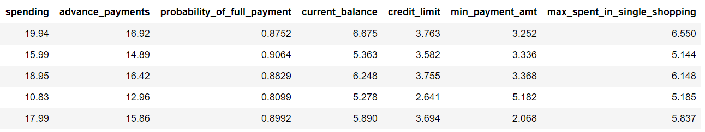

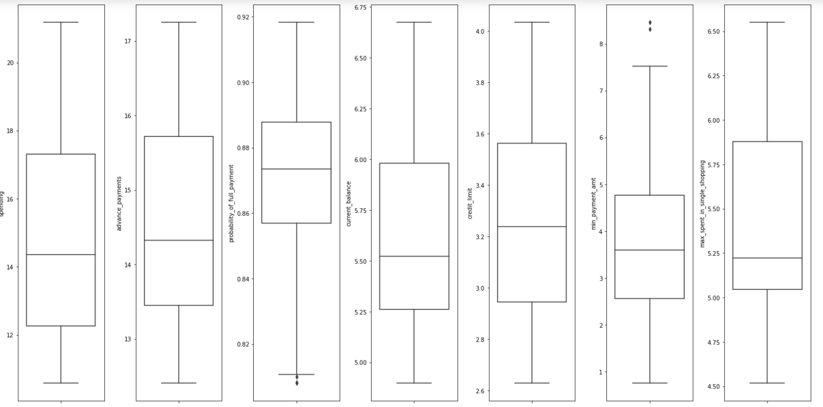

**Checking for outliers**

All outliers removed. These were in the lower range of the variable 'probability_of_full_payment' and the upper range of 'min_payment_amt'.

# The outliers are treated with the minimum and maximum value of inter-quartile range or IQR.   
# The outliers beyond the third quartile or Q3 are replaced with the upper limit.  
# The outliers below the first quartile or Q1 are replaced with the lower limit.

Fig 1: Boxplots for all variables

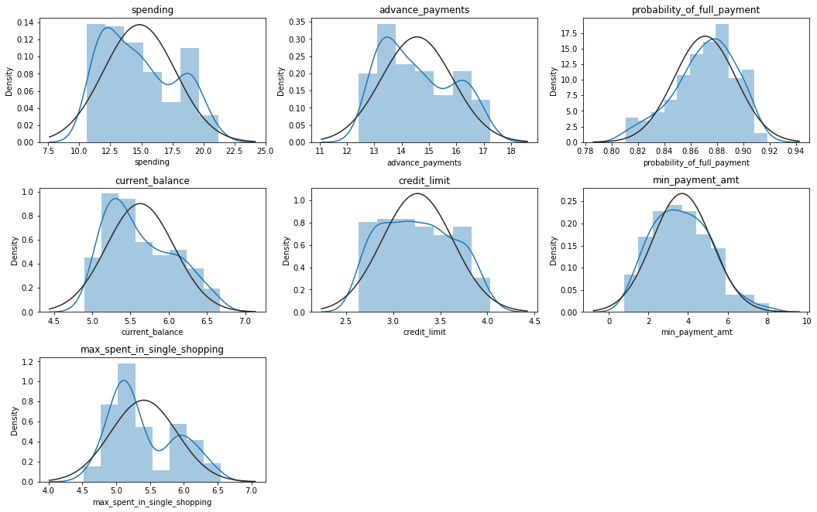

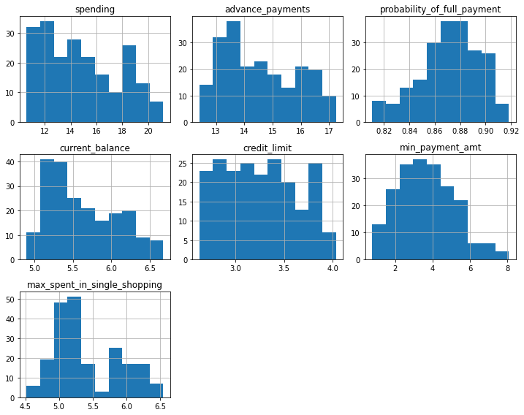

Fig 3: Distplots for all variables, showing also the Kernel Density Estimate line

None of the variables has perfect normal distribution. Most of the variabels are right skewed, while 'probability_of_full_payment' is left-skewed. In a left skewed distribution, the mean is less than the median. In a right skewed distribution, the mean is greater than the median. In a symmetrical or normal distribution, the mean, median, and mode are all equal. Symmetrical distributions are indicated by the black curve for reference, while the actual distribution curves are in blue. A distribution is left skewed if it has a “tail” on the left side of the distribution. A distribution is right skewed if it has a “tail” on the right side of the distribution.

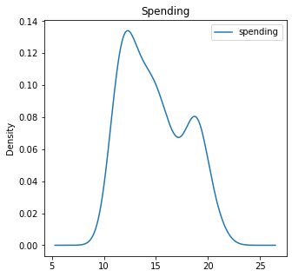

Fig 5: KDE plot for spending

Fig7: Heatmap to check correlations

Advance payments have a high correlation with spending, credit balance and credit limit. Maximum spending in single shopping has a high correlation with current balance. Minimum payment amount has a negative correlation with spending, probability of full payment, current balance, credit limit and advance payments (Notice the purple strip).

The KDE is calculated by weighting the distances of all the data points we’ve seen for each location on the blue line. If we’ve seen more points nearby, the estimate is higher, indicating that probability of seeing a point at that location. The density curve for probability of full payment has very low bandwidth and very high amplitude (almost 5 or 6 times). This means the probability of seeing a data point at that location is very slim. Not many people will ever make full payment. True, as there is never 100% surety of it.

**Checking for  
correlation**

There are quite a few instances of strong, linear correlation between variables, such as between spending and advance payments; advance payment and current balance; spending and credit limit; current balance and maximum spent in single shopping etc.

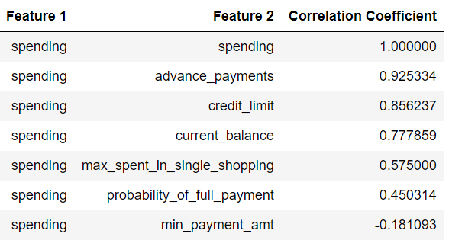

**Pairwise relationships.**

Fig 8: Pairplot

**Fig 9: Hued pairplot for current balance**

Current balance has six distinct groups. See legend

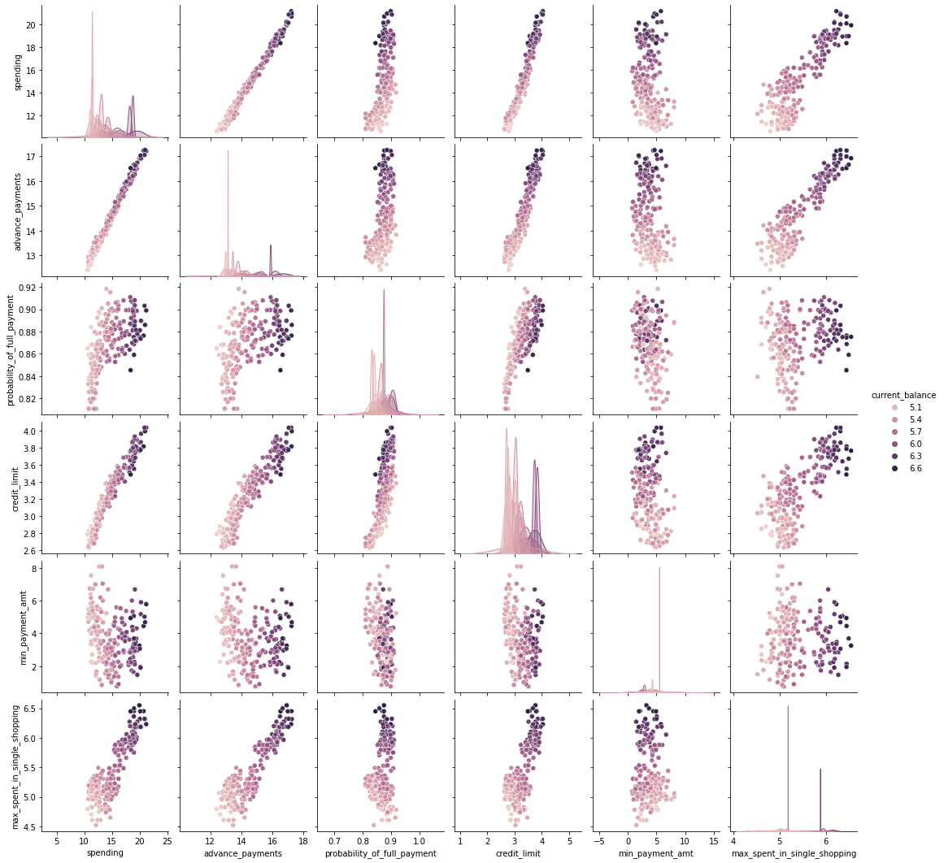

**Hued pairplots**

**Fig 10: Hued pairplot for spending**

Spending has five distinct groups. See legend.

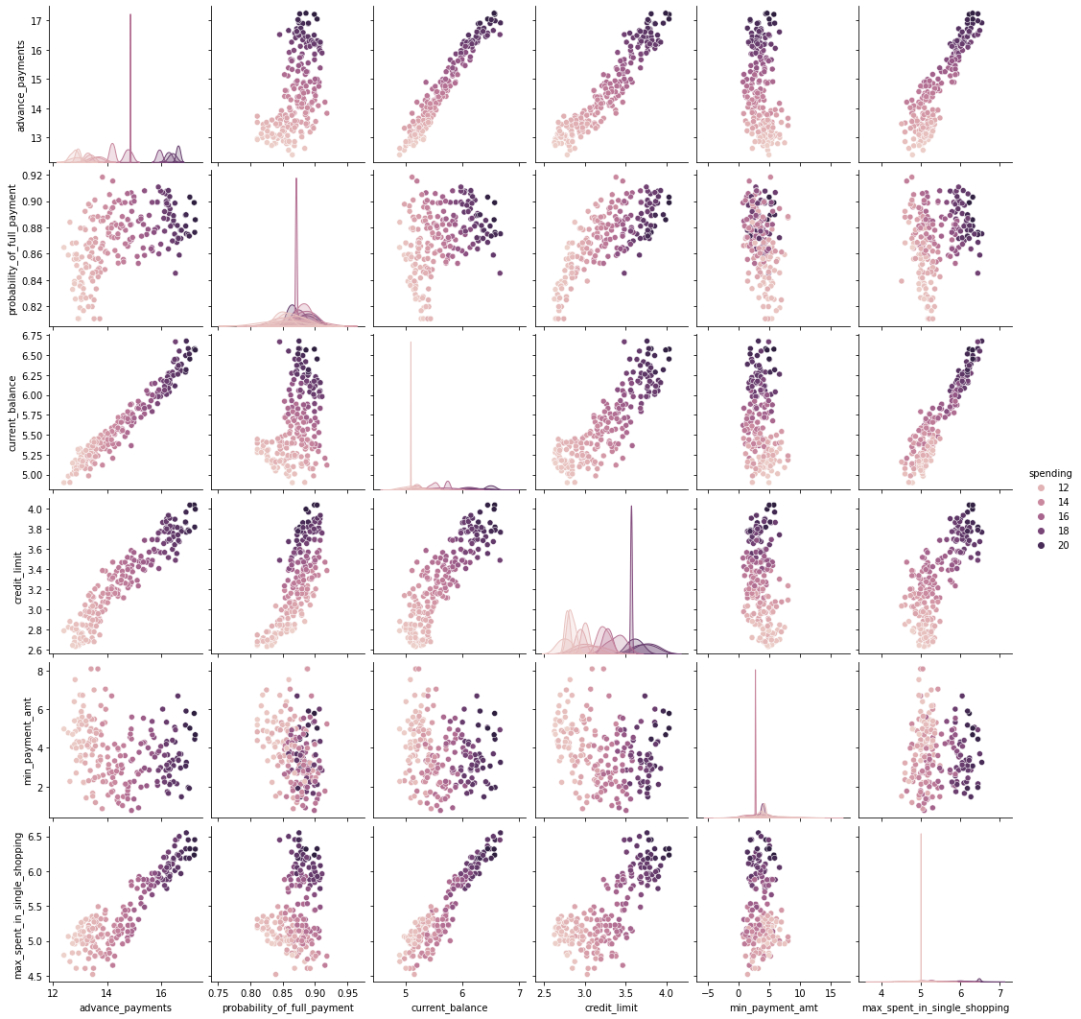

**Fig 11: Hued pairplot for maximum spend in single shopping**

Maximum spend in single shopping has five distinct groups. See legend.

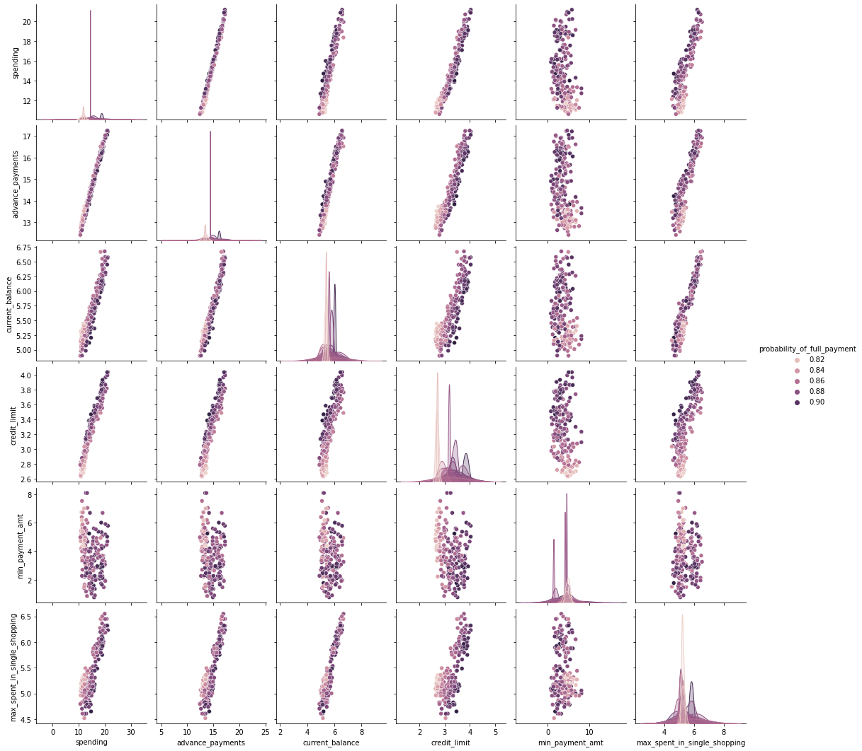

Fig 12: Advance payment. 5 groups

Advance payment has five distinct groups. See legend.

Fig 13.1: Probability of full payment. 5 groups

Fig 13: Credit limit  
6 groups

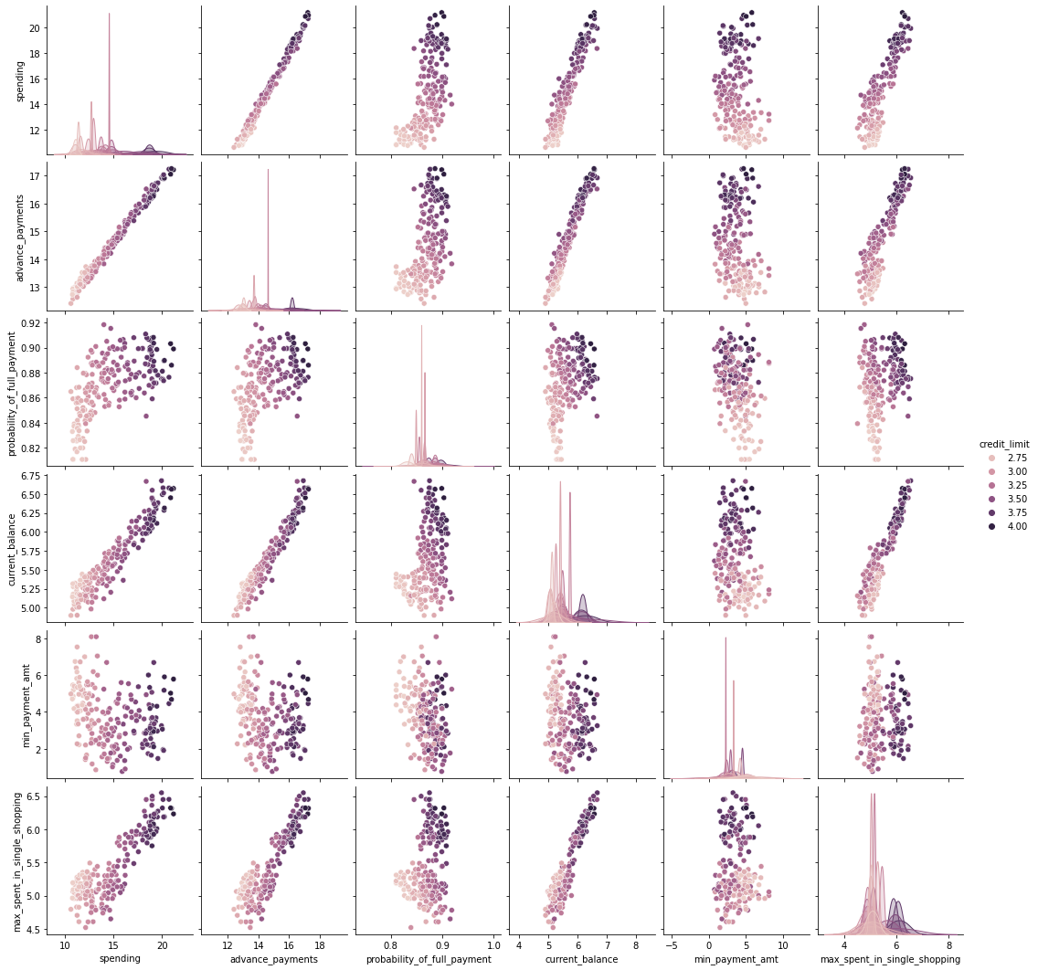

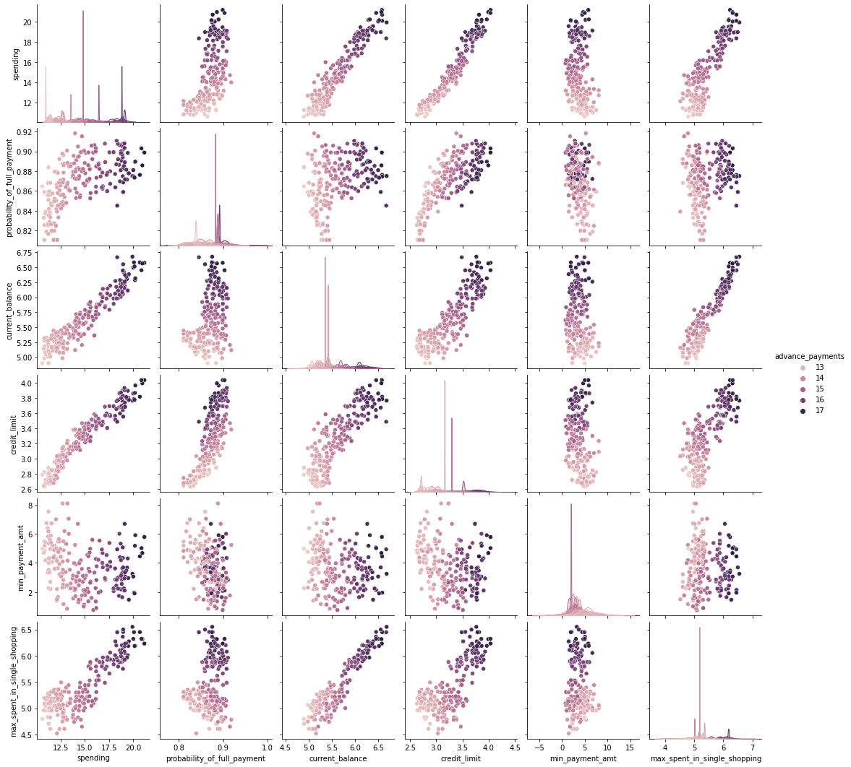

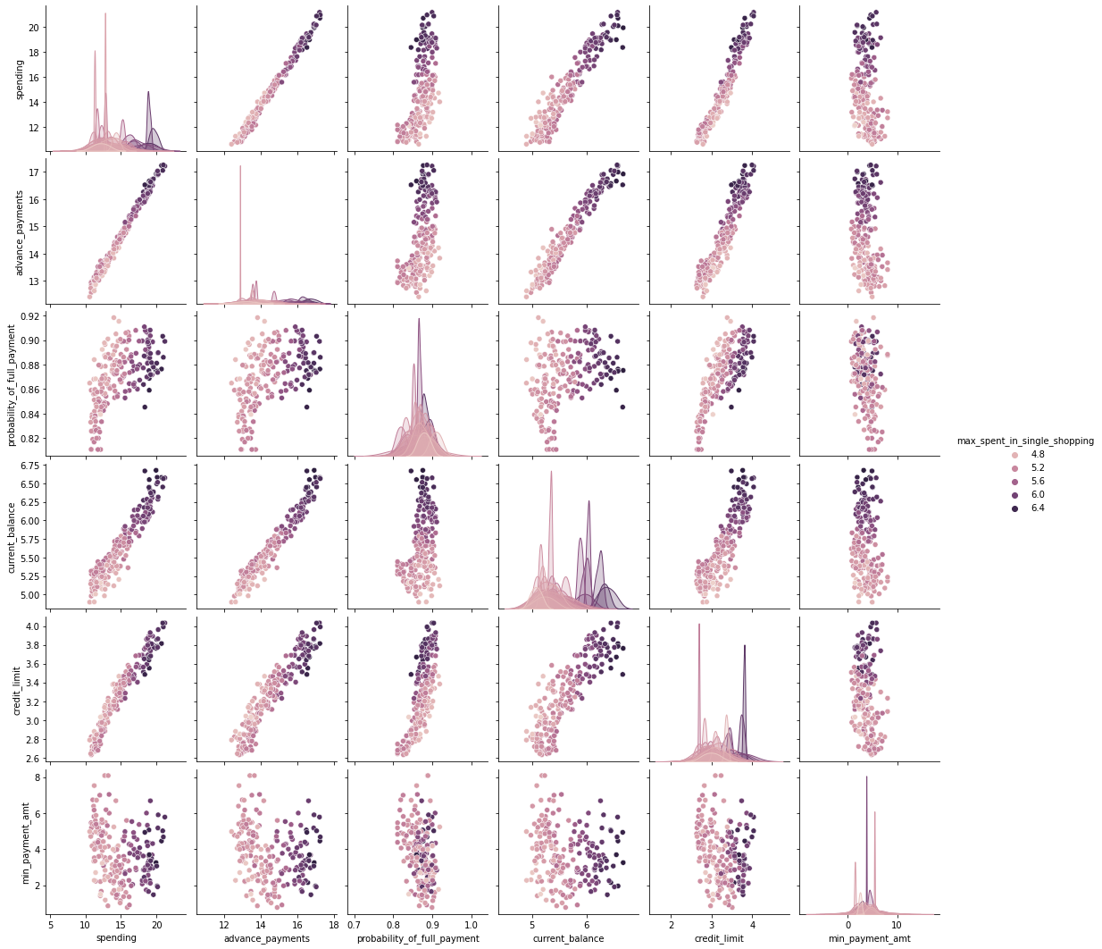

Tab 4: Five-number summaries for each variable

Checking columns

Index(['spending', 'advance_payments', 'probability_of_full_payment', 'current_balance', 'credit_limit', 'min_payment_amt', 'max_spent_in_single_shopping'], dtype='object')

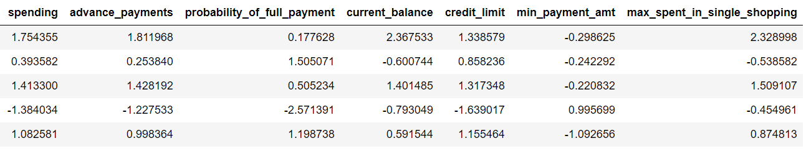

Tab 5: Scaled dataset, as evidence below by checking the mean and the standard deviation

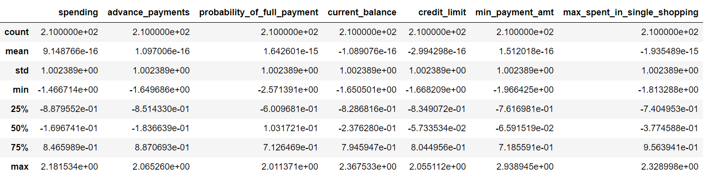



Fig 15: First dendrogram

**Distance matrix**

[[0. 4.84379711 1.26000488 ... 7.0105177 4.63461196 4.8895951 ]

[4.84379711 0. 3.59516985 ... 2.67724004 1.17640255 1.30574679]

[1.26000488 3.59516985 0. ... 5.858194 3.4773039 3.74469185]

...

[7.0105177 2.67724004 5.858194 ... 0. 2.39361362 2.28220521]

[4.63461196 1.17640255 3.4773039 ... 2.39361362 0. 0.87365342]

[4.8895951 1.30574679 3.74469185 ... 2.28220521 0.87365342 0. ]]

Fig 16: Big dendrogram

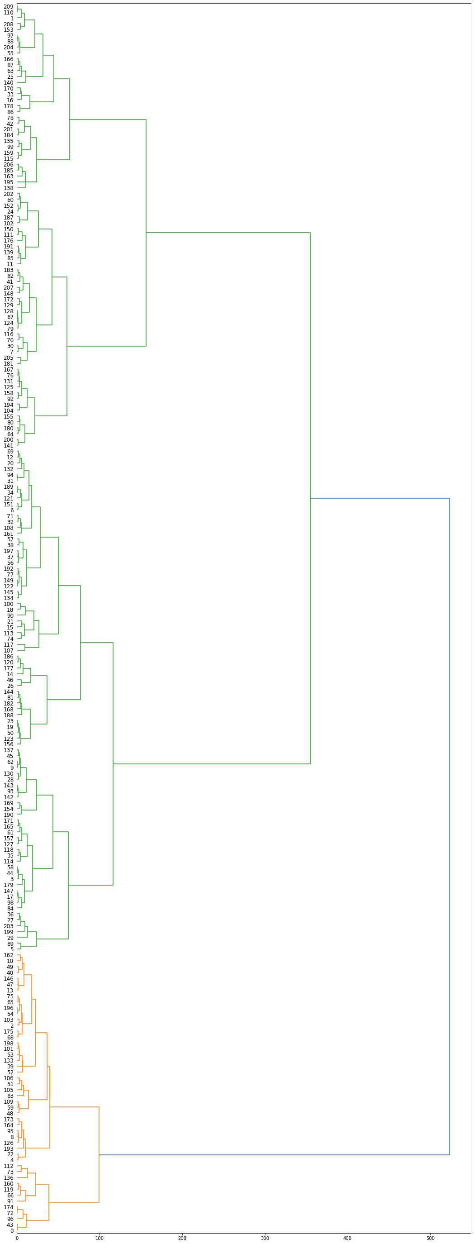

# Appending clusters to original database

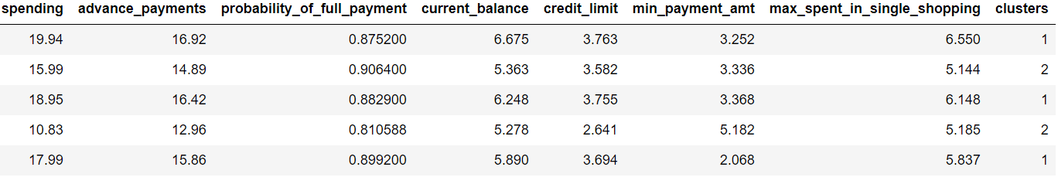

Tab 7: Data sets with clusters added

**Cluster profiles**

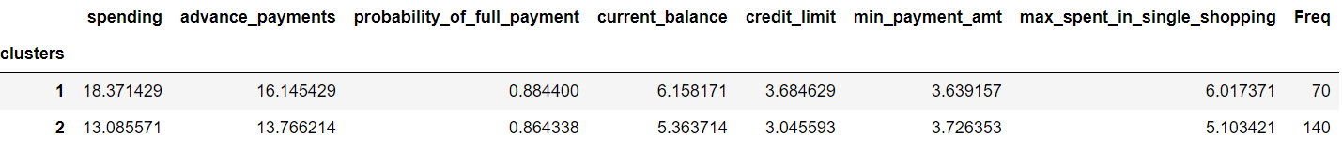

Tab 8: Data set pivoted on clusters and with frequency added

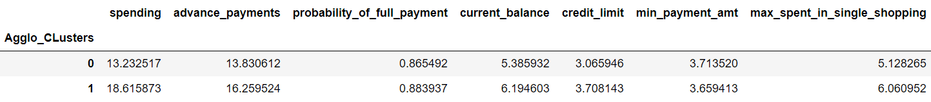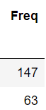

Tab 9: Dataset pivoted on agglomerative clusters

**Cluster 2: Low spenders** with less advance payment and lower average maximum spend in single shopping

**Cluster 1: High spenders** with more advance payment and higher average maximum spend in single shopping

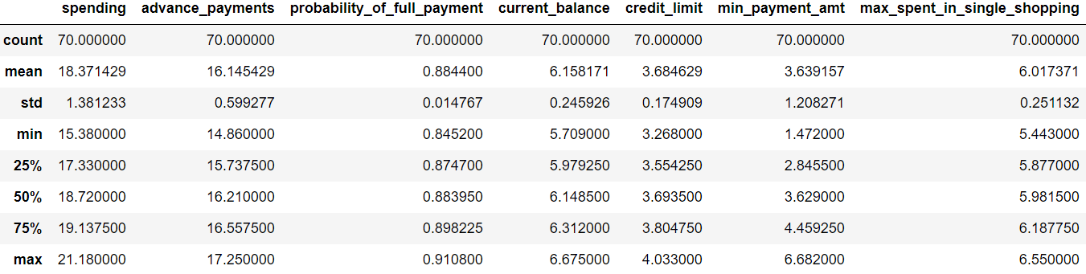

Tab 10: Data summary for cluster 1

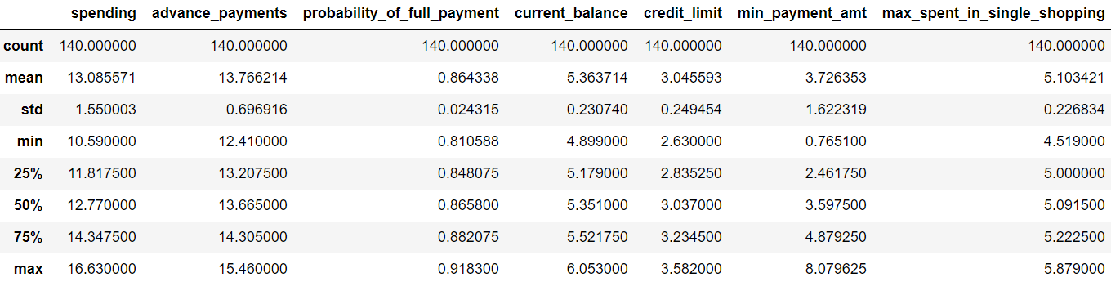

Tab 11: Data summary for cluster 2

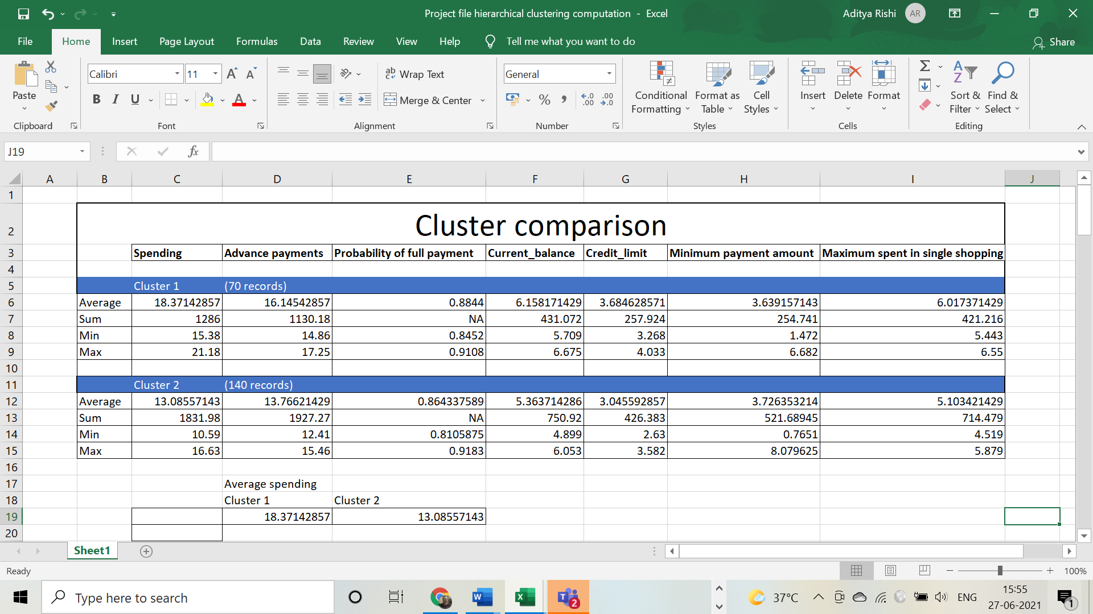

# Dataset with appended 3 clusters

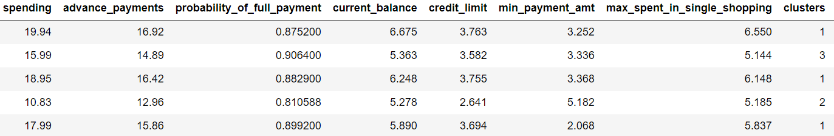

Tab 12: Dataset with appended 3 clusters

**Checking columns**

Index(['spending',  
'advance_payments',  
'probability_of_full_payment',  
'current_balance', 'credit_limit',  
'min_payment_amt',  
'max_spent_in_single_shopping',  
'Agglo_CLusters3'], dtype='object')

**Using Agglomerative Clustering**

Clusters=3  
Affinity=Euclidean  
Linkage=Ward

Agglomerative clusters

[0 1 0 2 0 2 2 1 0 2 0 1 2 0 1 2 1 2 1 2 2 2 0 2 1 0 1 2 2 2 1 2 2 1 2 2 2

2 2 0 0 1 0 0 2 2 1 0 0 0 2 0 0 0 0 0 2 2 2 0 1 2 2 1 1 0 0 1 0 2 1 2 0 0

2 0 1 2 0 1 1 1 1 0 2 1 1 0 0 2 2 0 1 2 2 0 0 0 2 0 2 0 1 0 1 0 0 2 2 0 1

1 0 2 2 0 1 2 2 0 1 2 2 2 1 1 0 2 1 1 2 1 1 0 2 0 0 2 0 1 1 1 2 2 1 2 0 2

1 2 1 2 1 1 1 1 1 2 1 0 0 2 0 0 0 2 0 1 1 1 1 2 1 0 0 0 1 1 0 2 1 1 1 1 0

0 1 1 1 2 1 1 2 0 1 0 0 2 0 2 1 0 1 2 0 1 0 1 0 1]

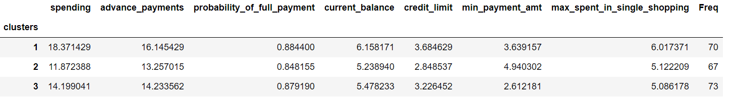

Tab 13: Dataset pivoted on three clusters, with appended frequencies

**Cluster  
profile**

Cluster sizes

1 70  
2 67  
3 73

Cluster 3: **Medium spenders** with advance payment level 14 and least minimum payment amount of all three segments

Cluster 2: **Low spenders** with high minimum payment amount and low credit limit

Cluster 1: **High spenders** with high advance payments

**Appended 3 agglomerative clusters**

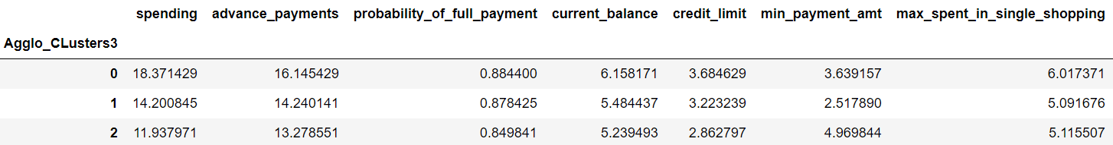

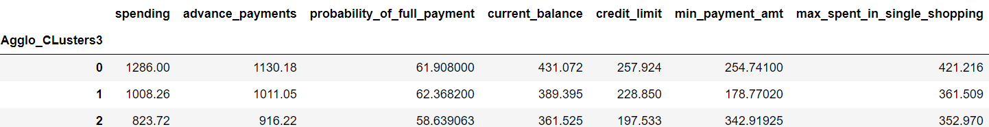

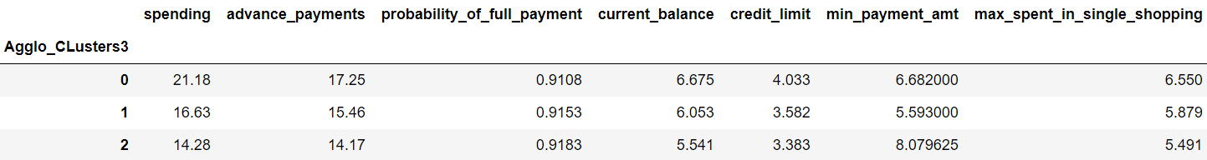

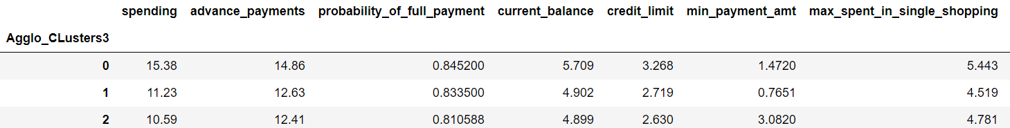

Tab 13,14,15,16: Dataset pivoted on 3 agglomerative clusters  
(versions: mean, sum, maximum, and minimum)

The output was saved to file and Excel graphs were made for the inference.

**Recommendations**

Beyond what has been proposed for the two categories before, here's something more we suggest:-

1. **Colour scheme:**

Using a simple colour scheme, the bank can introduce the gold, silver, and platinum cards for the three classes of customers, with a varying degree of benefits and special privileges such as extra points. Add higher limits, fees, reward points, and cache to higher cards.

2. **Loans:**

These cards can come with pre-approved loans (for housing, car, education, and retail), say silver for  
Rs 25 lakh, gold for Rs 25 lakh to Rs 50 lakh, and platinum for Rs 50 lakh to Rs 1 crore.

**3. Rating:**

The bank can start card-based credit rating to encourage more full payments.

**4. Show time:**

Run a scheme that allows card holders access to coveted show tickets before they are available to the general public. That'll encourage more spending across categories.

**9. Reward:**

Reward the customers for the length and size of business. This will encourage them to stay with the bank, which will save it the cost of acquiring new customers. Instead of validity date, the cards could say: "Member since".

**10. Use digital age:**

Allow customers to transfer money via smartphone using their card number at any time using. This will encourage more middle spenders towards cashless transaction.

**11. A card they can bank on:**

To attract low spenders towards using their credit card more often or exploring more of its applications, add traditional banking features such as account opening, money transfer, bill payment, and retail transactions, since this class has to queue up for most of these services, otherwise. The bank can also link it with subsidies.

**13. Hacker-proof:**

For high spenders at least, replace magnetic strip on the card with biometric authentication to make their accounts and transactions safer, as they will use biometric scans in place of PIN or password. Remember, their accounts are bank's cash cow.

**5. Link it to cash:**

The platinum card, which, in addition to quadrupling the gold card fees, could offer cash availability anywhere around the world without the need for a cheque, besides hotel upgrades when available and other travel and concierge services.

**6. Top class:**

Create a high-quality magazine aimed solely at the top segment (which will also make big money on the advertising on account of being desired by high-end vendors as one of the very few magazines targeted fully to their target audience. The vendors will minimize wasted advertising.

**7. Let's play:**

Offers exclusive performances and evenings with different artists, authors, actors etc. Top spenders should get IPL, Euro Cup, World Cup box tickets for sense of exclusivity and greater following.

**8. Boss card:**

Introduce high-end credit card differentiation. Beyond silver, gold, or platinum, call it "the Boss card" or something, so exclusive you shouldn't be able to apply for it. It's a "by invitation only" product, and the invitations are extended only to the most credit-worthy customers, who spend at least a certain high amount of money using their card annually. Put a price on it and the card should be hand delivered in a designer box. Exclusive customers seek exclusive items and experiences.

Looking into the cluster sizes across both algorithm

Tab 14: K-means 2 and K-means 3 cluster size comparison.

Silhouette score is better for 2 clusters than for 3 clusters. But we should also look at the elbow method. To determine the optimal number of clusters, we have to select the value of k at the “elbow”, i.e. the point after which the distortion/inertia starts decreasing in a linear fashion for the given data. We conclude that the optimal number of clusters for the data is 3. It also seems from the size comparison of the algorithms that KMeans model with 3 clusters has more evenly balanced observations. We'll go with 3 clusters.

KMeans with K=3

Clusters

array([0, 2, 0, 1, 0, 1, 1, 2, 0, 1, 0, 2, 1, 0, 2, 1, 2, 1, 1, 1, 1, 1,

0, 1, 2, 0, 2, 1, 1, 1, 2, 1, 1, 2, 1, 1, 1, 1, 1, 0, 0, 2, 0, 0,

**1.4 Apply K-Means clustering on scaled data and determine optimum clusters. Apply elbow curve and silhouette score.**

**KMeans**

K-means clustering is an unsupervised learning algorithm with a goal to find groups or assign the data points to clusters on the basis of their similarity. Which means the points in same cluster are similar to each other and dissimilar to those in different clusters. It was developed by researcher James Macqueen in 1967. Here K means the number of clusters. In order to find an appropriate number of clusters, the elbow method will be used. In this method for this case, the inertia for a number of clusters between 2 and 10 will be calculated. The rule is to choose the number of clusters where you see a kink or "an elbow" in the graph.

**Calculating Within Cluster Sum of Squares or WSS for 10 values of K**

[1469.999999999999,

659.14740095485,

430.298481751223,

370.6909292210199,

327.8379162768708,

294.70740950686735,

262.5742242335426,

240.20718392679387,

222.41512322267613,

205.2353741836641]

**Suggested model  
out of the two**

**Go with 3 clusters**

Since cluster analysis is essentially an exploratory approach, the interpretation of the resulting hierarchical structure is context-dependent and often several solutions are equally good from a theoretical point of view.

Even though cheaper, a generic credit card scheme tailored to the average will have the lowest response rate. A scheme that is tailored to each individual will have the highest cost. Three schemes tailored to three segments will be somewhere in between. This is the revenue side.

**The silhouette score** is best for 2 clusters but it's still far below 0.6. The score is only 0.46 or so, so, one the **clusters are not all that well separated**, and two**, the chances of calling it right are less than 50%**.

To maximize profit, the bank would want to keep segmenting until the marginal revenue from segmenting equals the marginal cost of segmenting. In this case study, our suggestion to the bank is to use three segments to maximize profit. The cost of losing a customer segment can be huge.

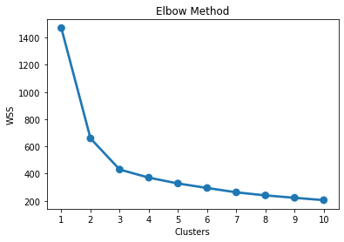

Fig 18.1: Line plot for the elbow method. WSS for 10 values of K are plotted on it.

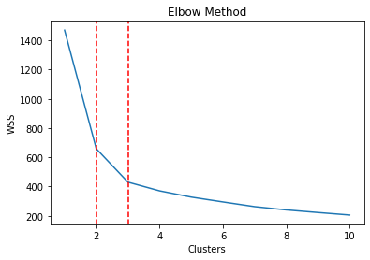

Fig 19.1: Double elbow marked in red.

**Silhouette scores for different clusters**

Silhouette score for 2 cluster k-means: 0.466  
Silhouette score for 3 cluster k-means: 0.401  
Silhouette score for 4 cluster k-means: 0.335  
Silhouette score for 5 cluster k-means: 0.281  
Silhouette score for 6 cluster k-means: 0.277  
Silhouette score for 7 cluster k-means: 0.276  
Silhouette score for 8 cluster k-means: 0.265  
Silhouette score for 9 cluster k-means: 0.272  
Silhouette score for 10 cluster k-means: 0.260

We have a double elbow, at 2 and 3 clusters, marked with vertical red lines. The other clusters have very little inertia.

**Looking into the cluster sizes  
across both algorithm**

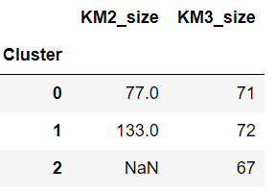

Tab 14: K-means 2 and K-means 3 cluster size comparison.

**Silhouette score is better for 2 clusters than for 3 clusters. But** we should also look at the elbow method. To determine the optimal number of clusters, we have to select the value of k at the **“elbow”,** i.e. the point after which the distortion/inertia starts decreasing in a linear fashion for the given data. **We conclude that the optimal number of clusters for the data is 3**. It also seems from the size comparison of the algorithms that KMeans model with 3 clusters has more evenly balanced observations. **We'll go with 3 clusters.**

**KMeans with K=3**

**Clusters**

array([0, 2, 0, 1, 0, 1, 1, 2, 0, 1, 0, 2, 1, 0, 2, 1, 2, 1, 1, 1, 1, 1,

0, 1, 2, 0, 2, 1, 1, 1, 2, 1, 1, 2, 1, 1, 1, 1, 1, 0, 0, 2, 0, 0,

1, 1, 2, 0, 0, 0, 1, 0, 0, 0, 0, 0, 1, 1, 1, 0, 2, 1, 1, 2, 2, 0,

0, 2, 0, 1, 2, 1, 0, 0, 1, 0, 2, 1, 0, 2, 2, 2, 2, 0, 1, 2, 0, 2,

0, 1, 2, 0, 2, 1, 1, 0, 0, 0, 1, 0, 2, 0, 2, 0, 2, 0, 0, 1, 1, 0,

2, 2, 0, 1, 1, 0, 2, 2, 1, 0, 2, 1, 1, 1, 2, 2, 0, 1, 2, 2, 1, 2,

2, 0, 1, 0, 0, 1, 0, 2, 2, 2, 1, 1, 2, 1, 0, 1, 2, 1, 2, 1, 2, 2,

1, 2, 2, 1, 2, 0, 0, 1, 0, 0, 0, 1, 2, 2, 2, 1, 2, 1, 2, 0, 0, 0,

2, 1, 2, 1, 2, 2, 2, 2, 0, 0, 1, 2, 2, 1, 1, 2, 1, 0, 2, 0, 0, 1,

0, 1, 2, 0, 2, 1, 0, 2, 0, 2, 2, 2])

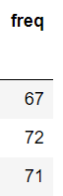

# The three customer segments are similar to the ones detected by hierarchical clustering model. We'll describe these, later.

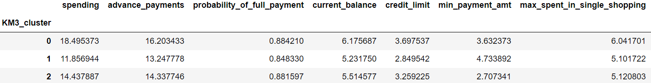

Tab 16: Dataset pivoted on K-means 3 clusters, with appended frequencies.

**Appending clusters to the original dataset**

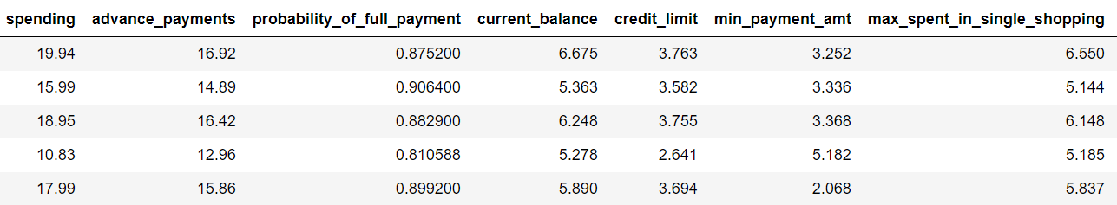

Tab 15: Dataset with appended K-means 3 cluster  
Output saved in .csv file and graphs made on the basis.

Cluster profiling

0 67  
1 72  
2 71

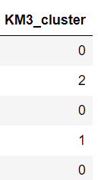

**Model evaluation**

Computing silhouette width¶

array([0.5732776 , 0.36556355, 0.63709249, 0.515595 , 0.36097201,

0.22152508, 0.47529542, 0.36025848, 0.51938329, 0.53443903,

0.46599399, 0.12839864, 0.39177784, 0.52379458, 0.11202082,

0.22512083, 0.33760956, 0.5018087, 0.03635503, 0.23801566,

0.36177434, 0.3693663, 0.43153403, 0.26364196, 0.47484293,

0.06663956, 0.27151643, 0.50414367, 0.55487254, 0.43479958, **…**  
…

0.55091698, 0.45775599, 0.04751093, 0.08299646, 0.44235462,

0.48260857, 0.07809599, 0.27491244, 0.40433159, 0.24770267,

0.33999491, 0.04992993, 0.40361423, 0.36916642, 0.45685928,

0.00276854, 0.36816915, 0.49743358, 0.54713282, 0.48730846,

0.26508389, 0.59700311, 0.39850516, 0.61330409, 0.47290575,

0.52337193, 0.09672676, 0.51720179, 0.5116529, 0.0473538,

0.30803559, 0.26742336, 0.5059218, 0.25717369, 0.04206292])

**Checking for any negative silhouette width**

The minimum silhouette width is on the positive side of zero but not closer to 1, so there are clusters, even though not well separated. There is no record with negative silhouette score, which means that the classification was proper. The model is verified.

Minimum silhouette width  
**0.0027685411286160638**

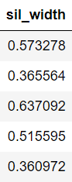

**Appending silhouette width to dataset**

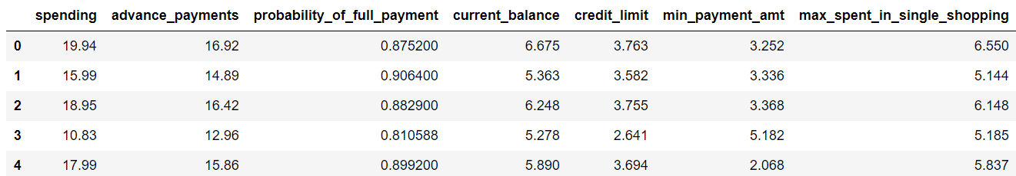

Tab 17: Dataset with appended silhouette width

Showing **silhouette score** once again. It's the average of the silhouette widths.

**0.4008059221522216**

**High spenders cluster description**

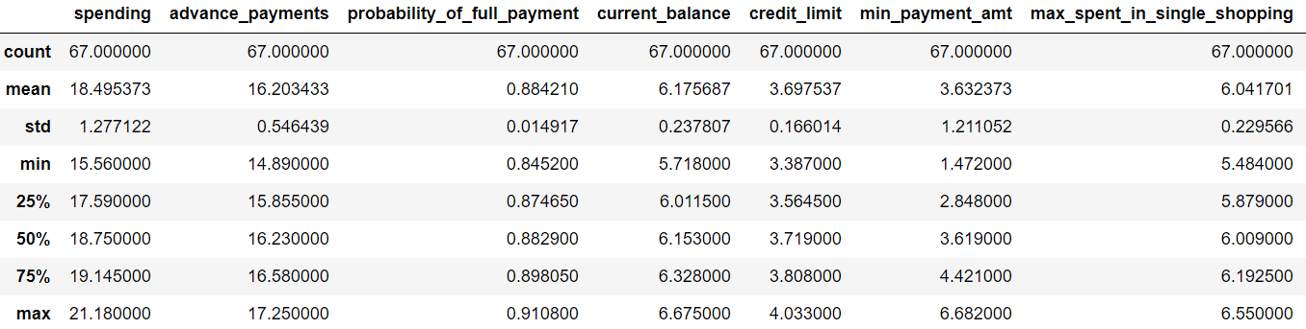

Tab 18: Data summary for high spenders

**Low spenders cluster description**

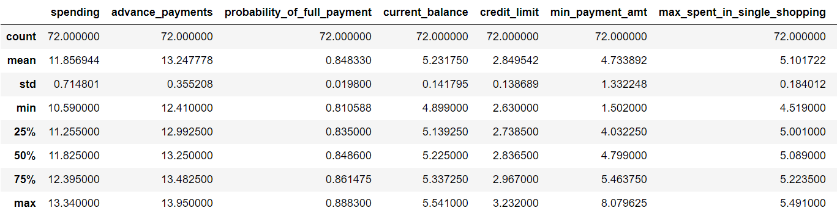

Tab 19: Data summary for low spenders

**Medium spenders cluster description**

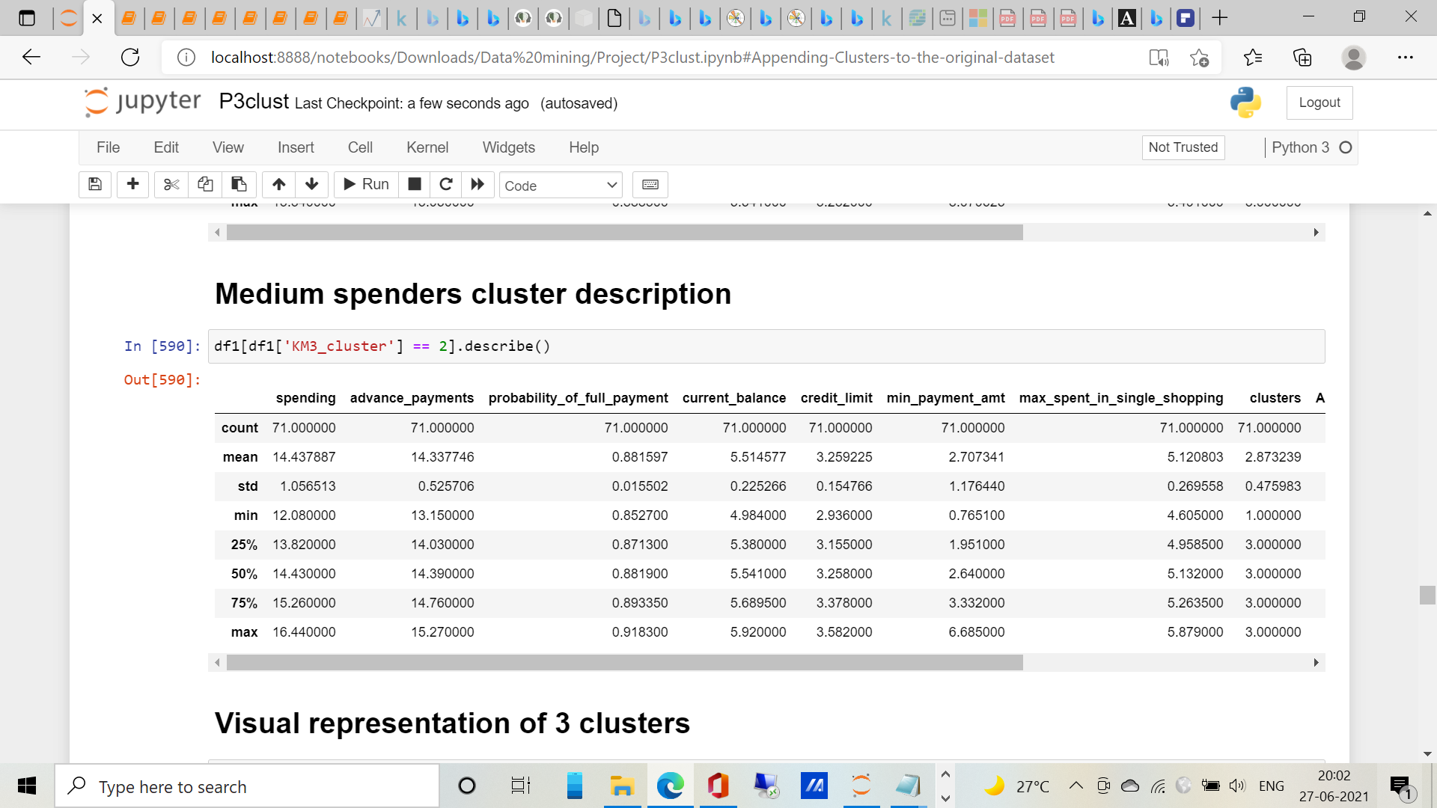

Tab 20: Data summary for high spenders

­

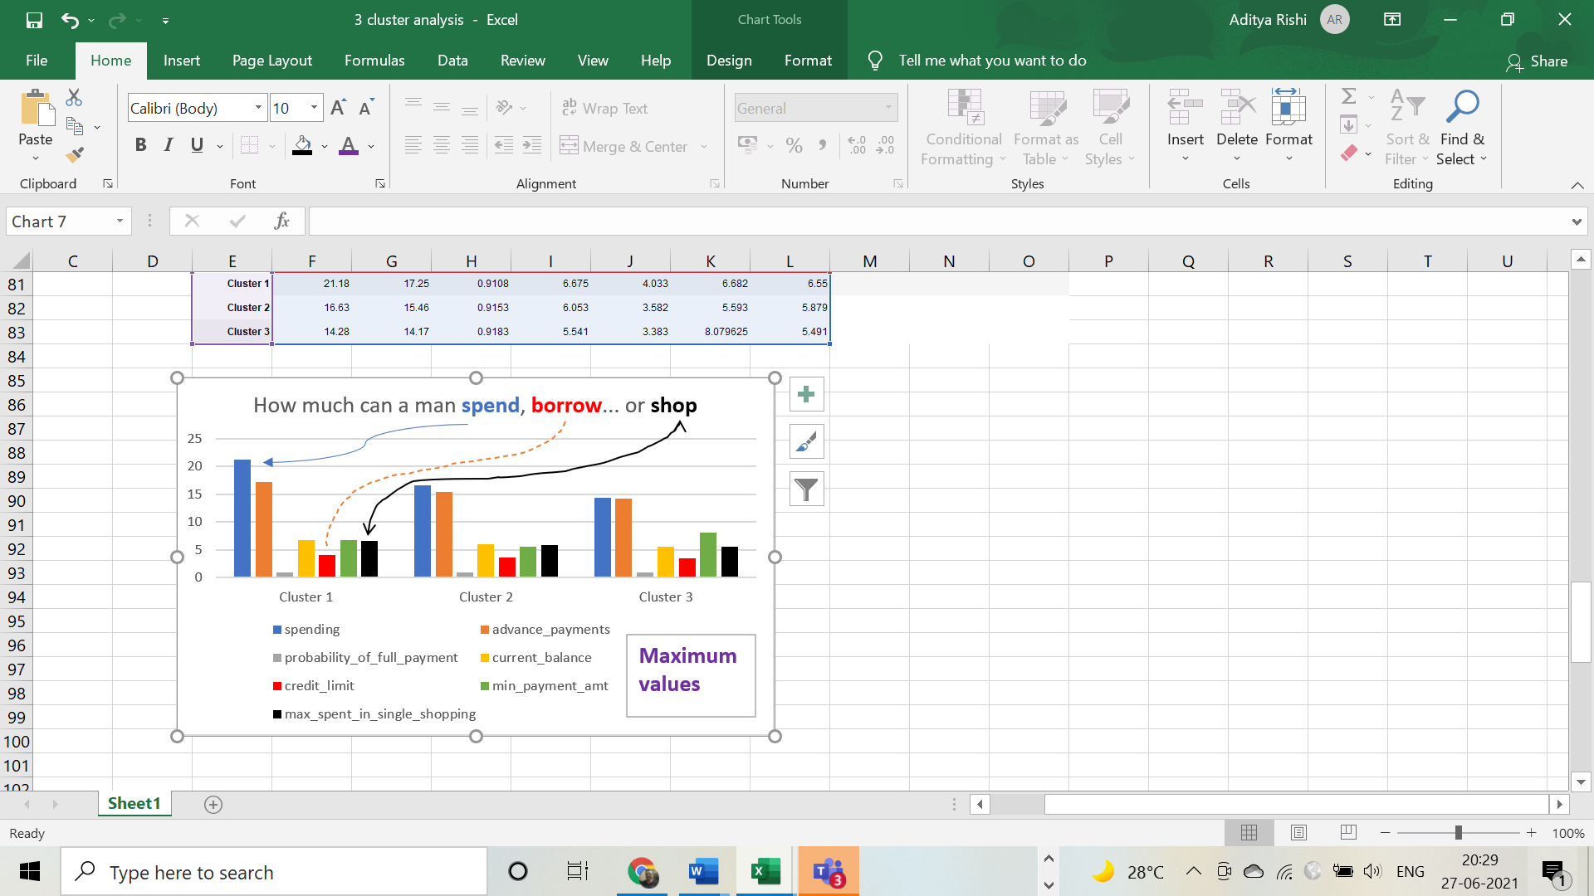

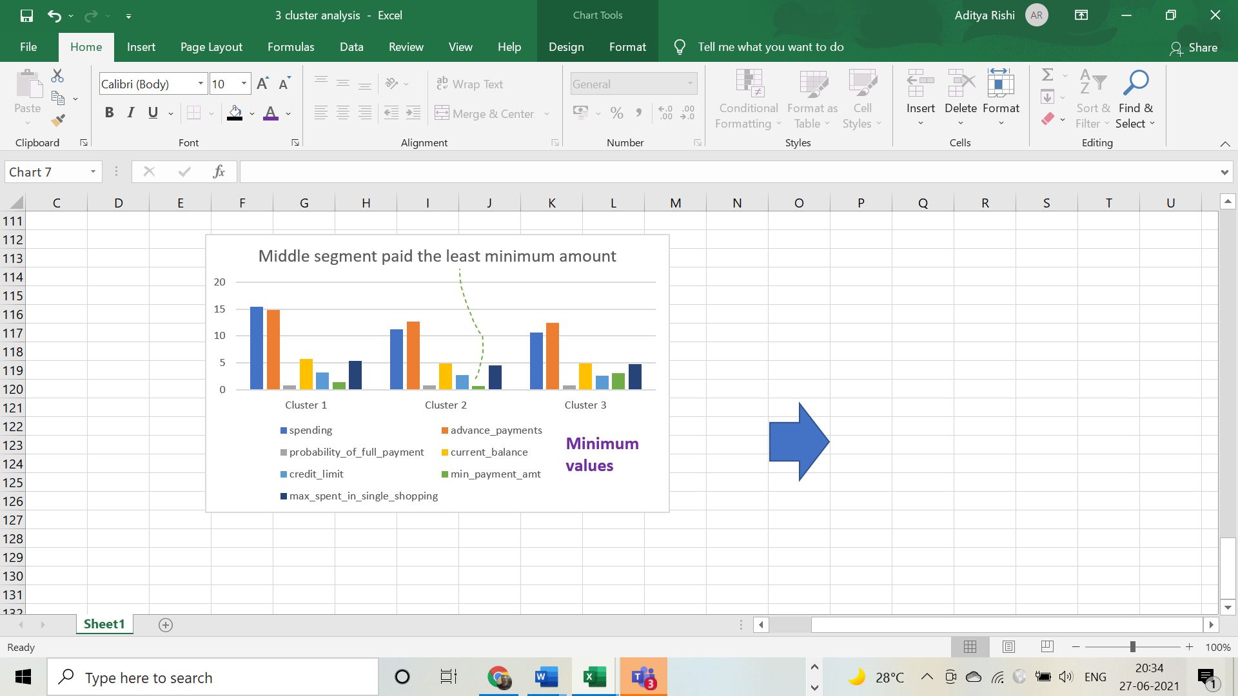

**Visual  
representation  
of 3 clusters**

**Customers in  
each cluster**

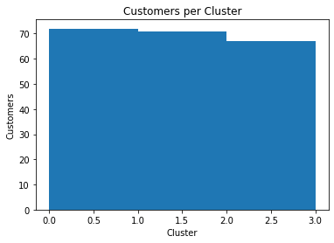

**Variable histograms for each cluster**

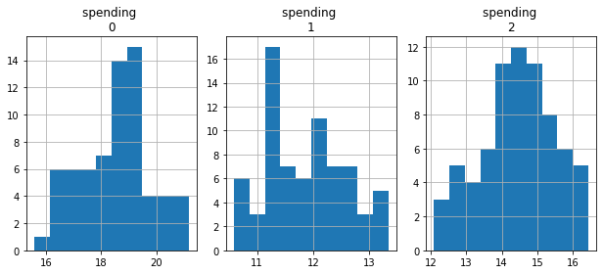

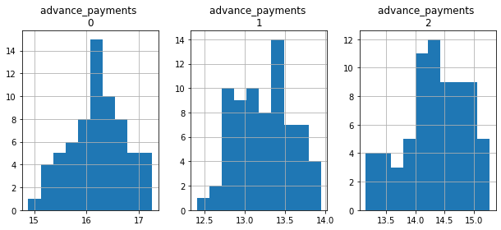

Fig 20: Variable histograms for each cluster

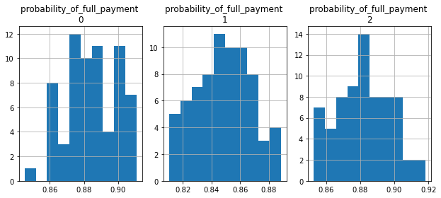

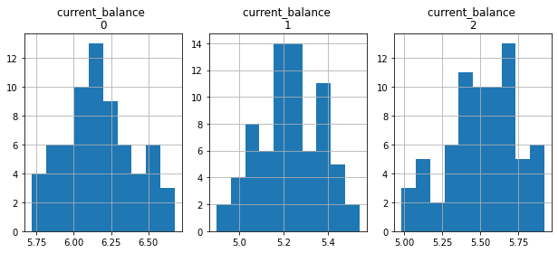

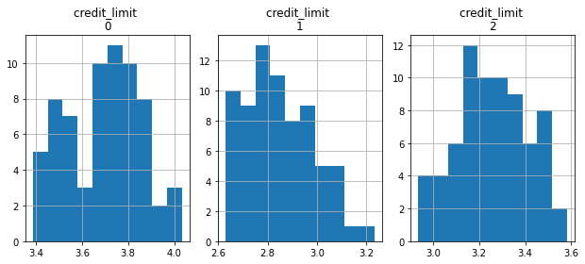

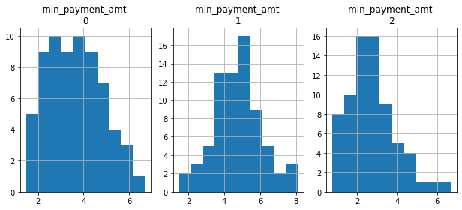

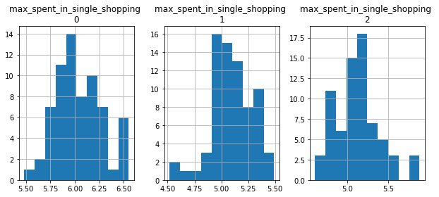

Scatter plot

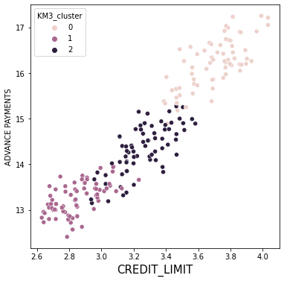

Fig 21: Scatterplot of credit limit and advance payments, hued on K-means 3 clusters

Pairplot hued on KM3 clusters.

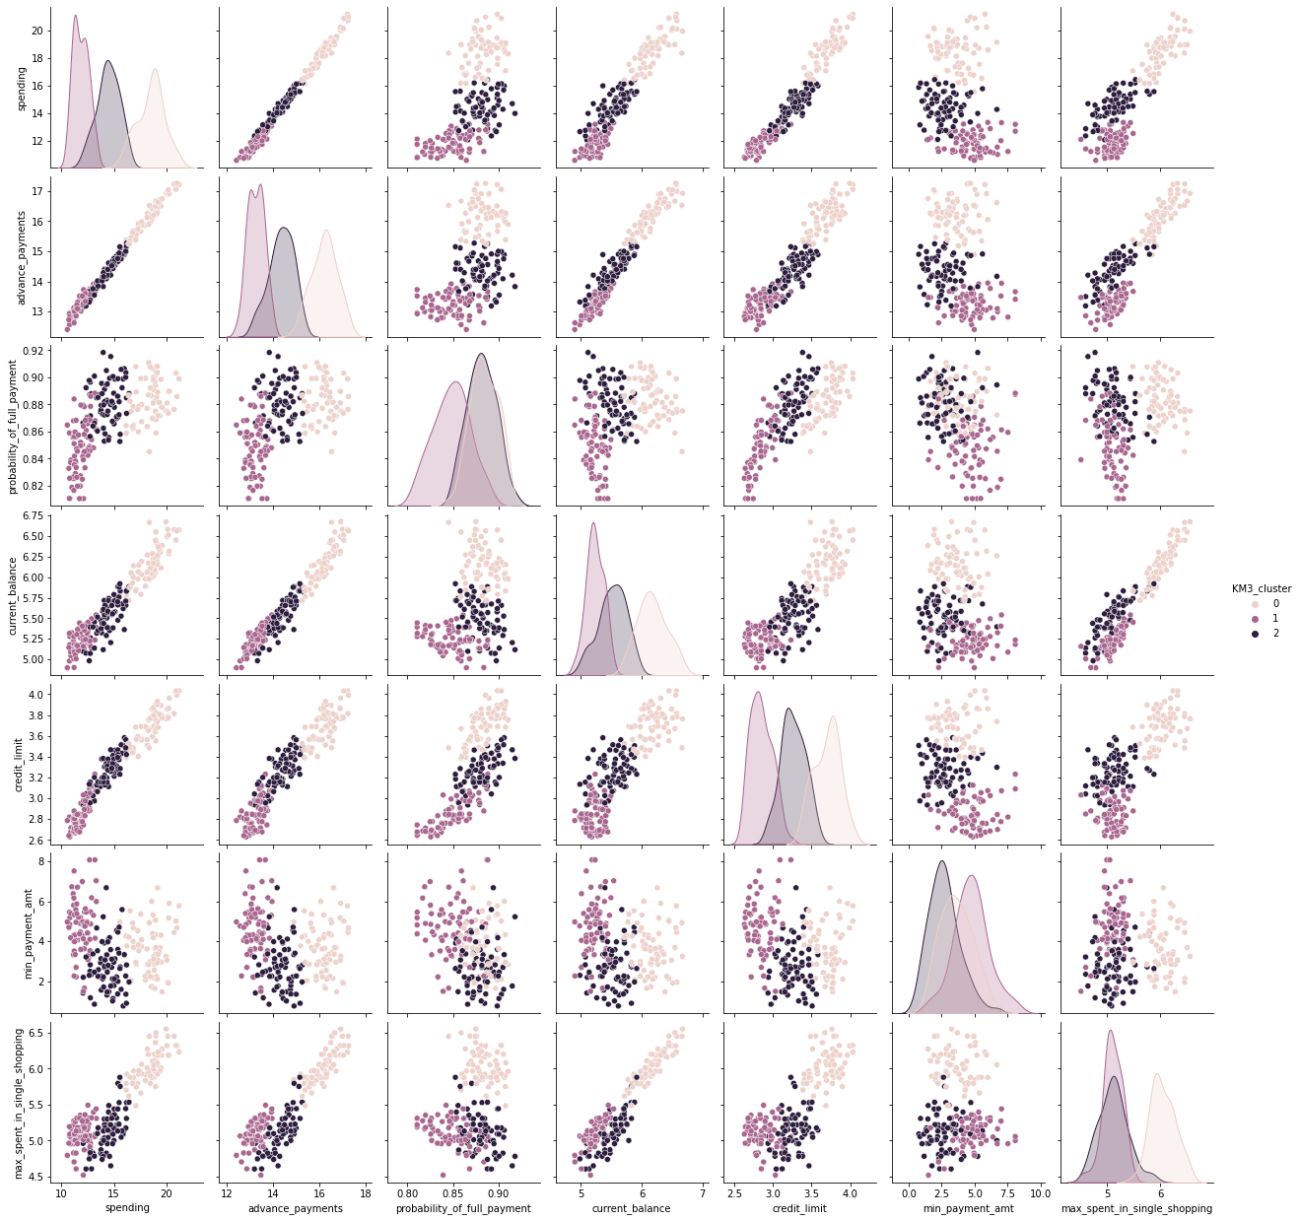

Fig 22: Pairplot hued on KM3 clusters. Quite different from the previous hued pairplots.

Different variables against advance payment

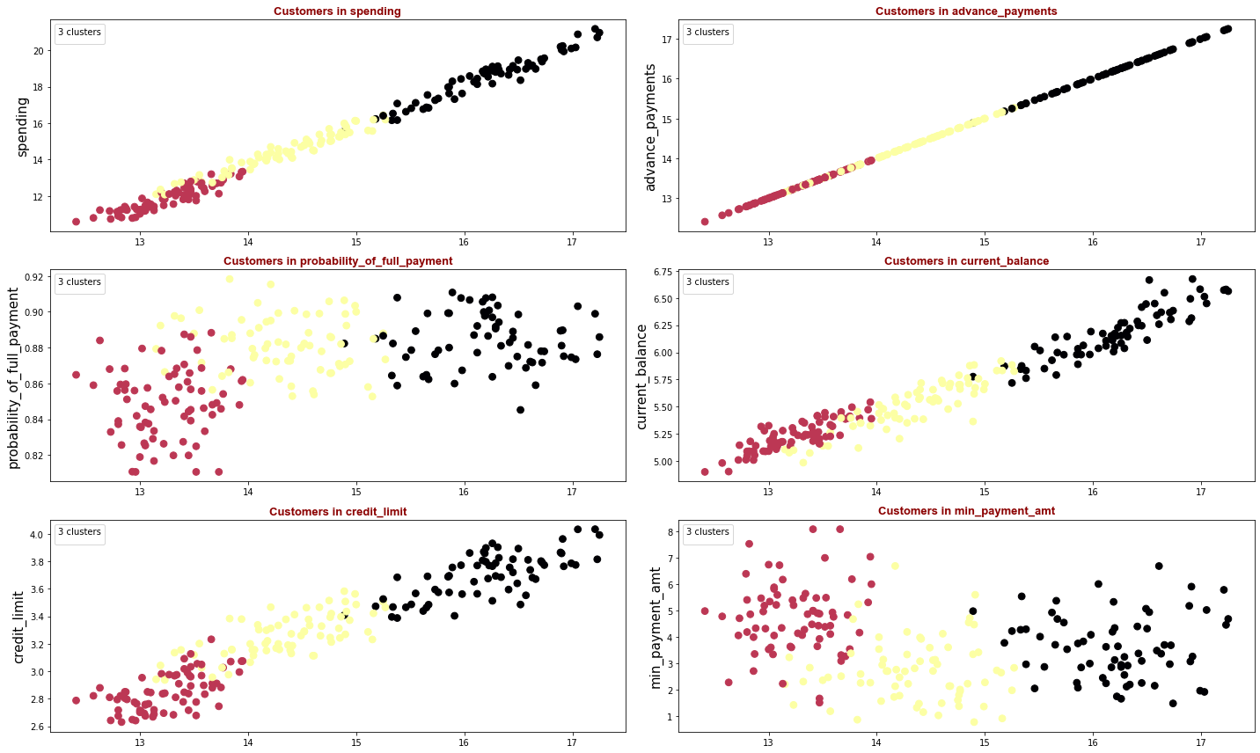

# Fig 23: Scatter plots of different variables against advance payment.

**Indicated:** Customers with small, medium, and large spending, advance payments, and credit limit. Low spenders make a higher minimum payment. A customer segment indicated in black has credit limit way lower in comparison with their spending and advance payments. Probability of full payment is higher for the group marked in black.

Cluster details

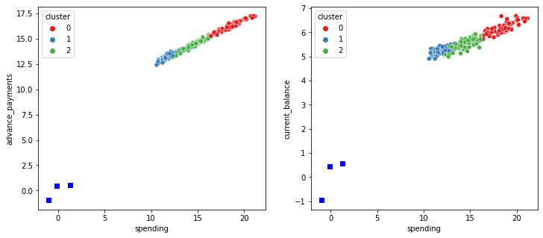

Fig 24: Spending against advance payments and current balance.

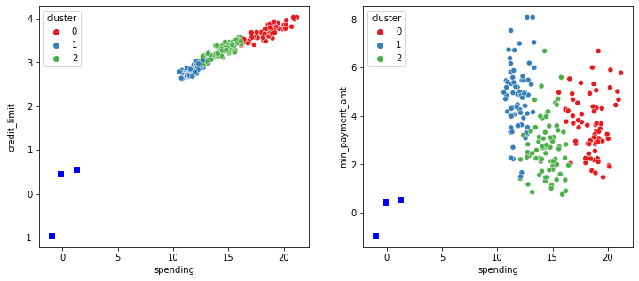

Fig 24: Spending against credit limit and minimum payment amount.

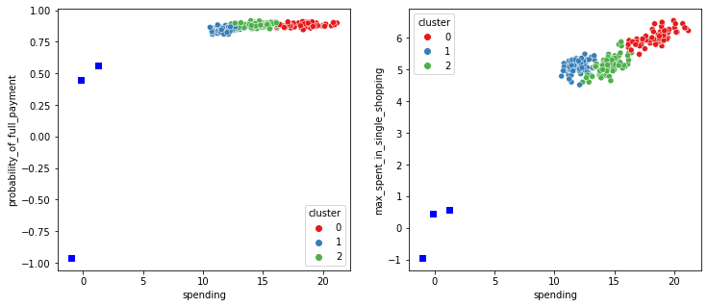

Fig 26: Spending against probability of full payment and maximum spent in single shopping.

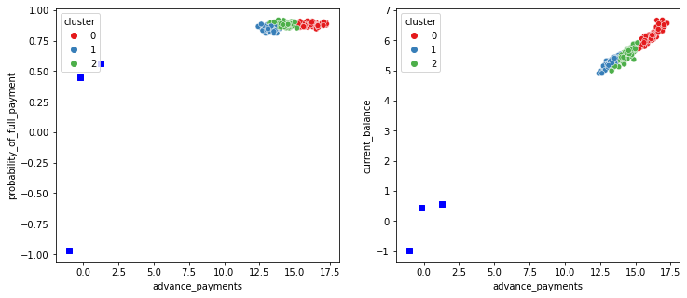

Fig 27: Advance payments against probability of full payment and current balance.

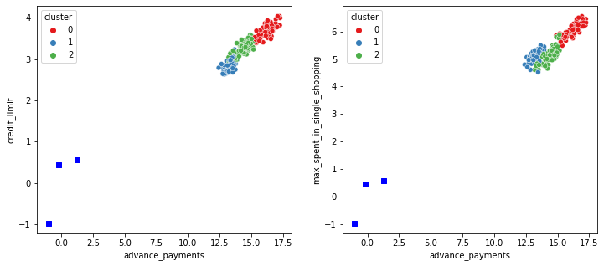

Fig 28: Advance payments against credit limit and maximum spent in single shopping.

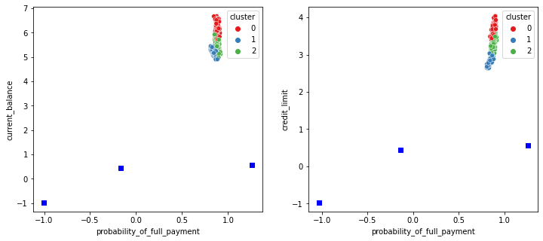

Fig 29: Probability of full payment against current balance and credit limit.

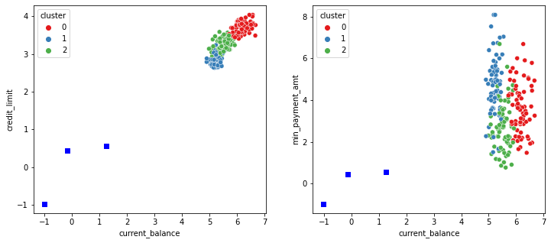

Fig 30: Current balance against credit limit and minimum payment amount.

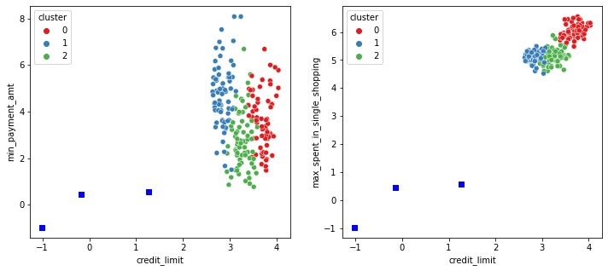

Fig 31: Credit limit against minimum payment amount and maximum spent in single shopping.

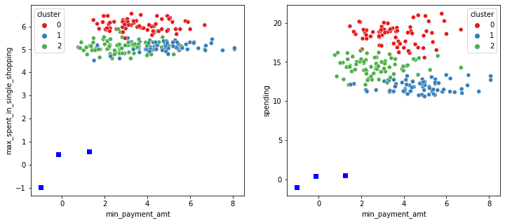

Fig 32: Minimum payment amount against maximum spent in single shopping and spending.

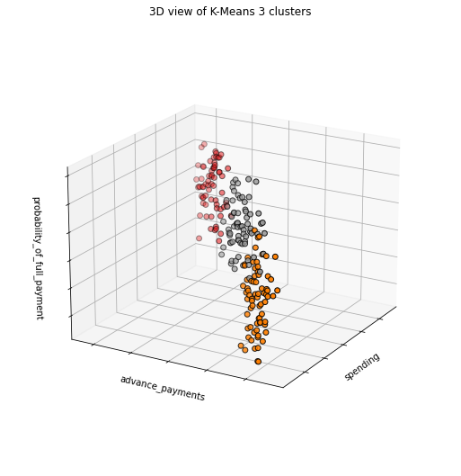

Fig 33,34,35,36: 3-D views of K-means 3 clusters

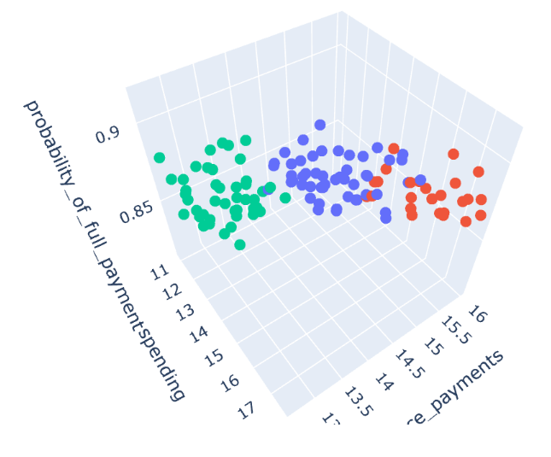

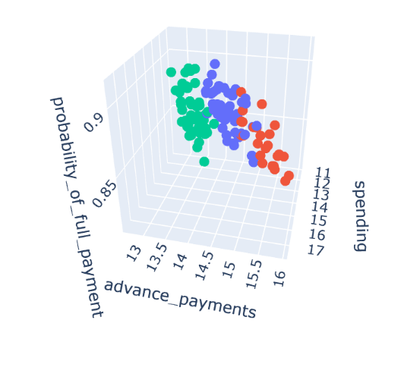

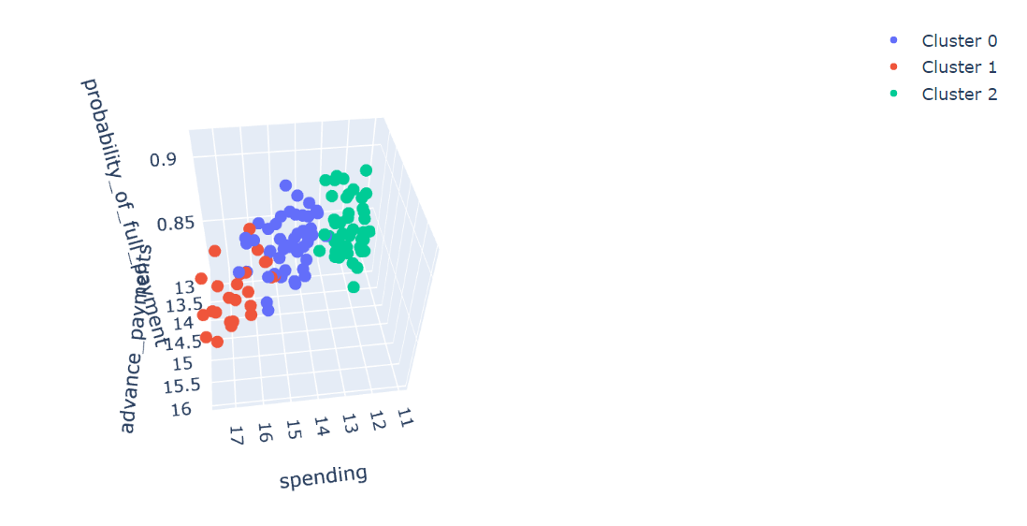

**Conclusion**

After executing various methods, we choose Kmeans, since the data does not include different small groups but group that are very similar to each other. For record sake, we did try out density-based algorithms but, one, it was out of the scope of this project, and two, we did not prefer to use those based on the results. Those algorithms, though, can help us seek out extreme customers in credit card fraud. This study aims customer segmentation by using customer behaviour.

Compering 2 different Kmeans models showed that we have a better understanding of customer segmentation by using the 3-cluster model.

**Some of the outstanding results:**

**Cluster 1:** This customer group indicates a small group of customers who are high spenders with high advance payment. We can also assume that this customer segment uses its credit card as a loan. They may want the bank to increase their credit limits so that they are able to keep their spending habits.

**Cluster 2:** These customers purchase frequently but use their credit cards for a small number of purchases.

**Cluster 3:** This segment points out new or low-spending customers with a lower credit limit and current balance. It is a similar customer segment as cluster 2 but with a lower average spending.

Since this was an experiment and not part of the project, it was done with K-means 4 and K-means 5. DBSCAN works best on large data. This page is just for fun.

And the winner is…

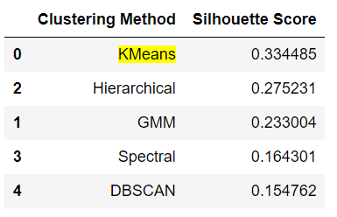

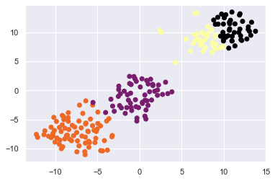

T-SNE

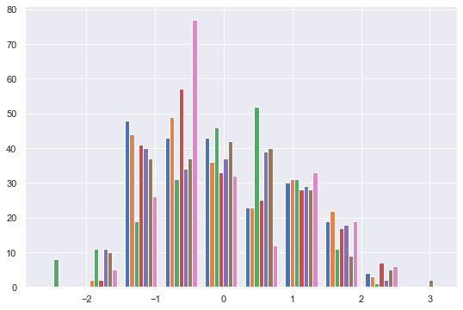

Spectral clustering: 7 clusters, mainly

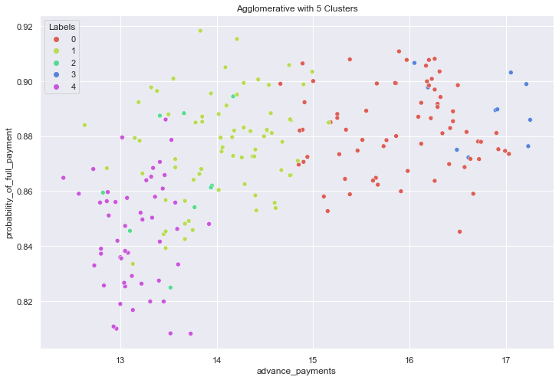

Agglomerative clustering picked 5 clusters

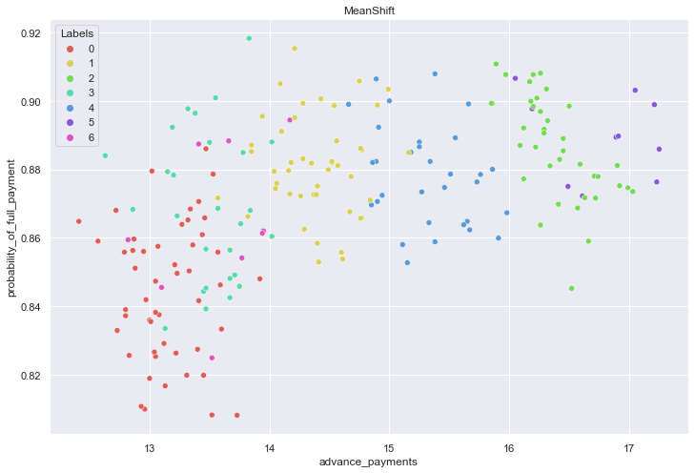

Mean Shift created 7 clusters

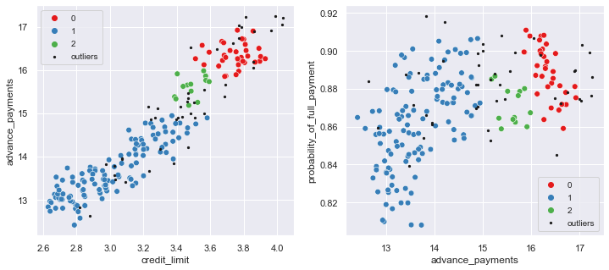

# DBSCAN created 3 clusters plus the outliers cluster (-1).

# Sizes of clusters 0-2 vary significantly - one has 13 observations, while another has 118. There are 45 outliers.

**K-means in race against other clustering algorithms**  
Small experiments with data, for bonus points 😊

# Problem 2: CART-RF-ANN

**Editorial summary**

An Insurance firm providing tour insurance is facing higher claim frequency. The management decides to collect data from the past few years. We are assigned to make a model that predicts the claim status and provides the management with recommendations. We are asked to use CART, RF & ANN, and compare the models' performances in train and test sets.

**Introduction**

Even before Covid-19, countries such as Britain had a staggering 10 times increase in customer inquiries, claims and complaints relating to their travel insurance. Whether it's about travel insurance, critical illness, health cover, business interruption, or another issue, customers are deluging insurers with queries over what they may or may not be covered for or to actually make a claim. An insurance claim is a formal request to an insurance company asking for a payment based on the terms of the insurance policy. The insurance company reviews the claim for its validity and then pays out to the insured or requesting party (on behalf of the insured) once approved. One of the biggest challenges is that all of this is happening at the same time as a huge spike in customer contact.

This is a predictive analysis problem under classification and CART (classification and regression trees), Random Forest, and Artificial Neural Network are all classification techniques.

Decision tree is a non-parametric supervised machine learning algorithm which is used mostly for classification and regression problems. In this scenario, we split the population or sample into two or more homogeneous sets (or subpopulations) based on the most significant splitter/differentiator in input variables.

If there is high non-linearity and complex relationship between dependent and independent variables, a tree-based model will outperform a classical regression method. And yet, if we need to build a model which is easy to explain to people, a decision tree model will always do better and be simpler to interpret than linear regression.

Decision tree can automatically handle missing values.

Decision tree is usually robust to outlier and can handle them automatically.

Training period is less as compared to Random Forest because it generates only one tree unlike forest of trees in the Random Forest.

**Disadvantages of Decision Tree**

Overfitting is the main problem of decision tree. It generally leads to overfitting of the data which ultimately leads to wrong prediction.

Due to the overfitting, there are very high chances of high variance in the output which leads to many errors in the final estimation and shows high in accuracy in the results.

Adding a new datapoint can lead to re-generation of the overall tree and all nodes need to be recalculated and recreated.

Decision tree is not suitable for large datasets. If the dataset is large, then one single tree may grow complex and lead to overfit. So, in that case, we should use random forest instead of a single decision tree.

**Important terminology related to Decision Tree**

**Root Node:** It represents the entire population or sample and this further gets into two or more homogeneous sets.

**Splitting:** It is a process of dividing a node into two or more sub nodes.

**Decision Node:** When a sub-node splits into further sub nodes, then it is called the decision tree.

**Leaf/Terminal Node:** Nodes do not split is called leaf or terminal node.

**Pruning:** When we remove sub-nodes of a decision node, this process is called pruning.

**Branch/Sub-Tree:** A subsection of the entire tree is called branch/sub tree.

**Parent and Child Node:** A node, which is divided into sub nodes is called a parent node of sub nodes whereas sub nodes are the child of a parent node.

Then we come to Artificial Neural Network, which is a Machine Learning algorithm that is modelled roughly around what we know currently about how the human brain functions. ANN Models the relationship between a set of input signals and an output, similar to a biological brain response to stimuli from sensory inputs.

The brain uses a network of interconnected cells called neurons to provide learning capability, while ANN uses a network of artificial neurons or nodes to solve challenging learning problems. ANNs have the ability to learn and figure out how to perform their function on their own.

ANNs determine their function based only on sample inputs. ANN also has the ability to generalize and produce outputs for inputs it has not been taught how to deal with. Besides, it can be easily retrained to suit a new environment.

The problem at hand:- The objective will be to try out the three models and check which one has the strongest predictive power so as to call most correctly if a customer will file for claim.

**Attribute Information:**

**1.** Target: Claim Status (Claimed)

**2.** Code of tour firm (Agency_Code)

**3.** Type of tour insurance firms (Type)

**4.** Distribution channel of tour insurance agencies (Channel)

**5.** Name of the tour insurance products (Product)

**6.** Duration of the tour (Duration)

**7.** Destination of the tour (Destination)

**8.** Amount of sales of tour insurance policies (Sales)

**9.** The commission received for tour insurance firm (Commission)

**10.** Age of insured (Age)

** In the tour insurance dataset, the variable ‘commission’ is misspelt but not so grossly as to be misunderstood.

# 

Tab 1: The dataset

# 2.1 Data Ingestion: Read the dataset. Do the descriptive statistics and do null value condition check, write an inference on it.

### Data above, details below

3,000 entries, 0 to 2,999  
Total 10 columns

# Column Non-Null Count Dtype   
--- ------ -------------- -----   
 0 Age 3000 non-null int64   
 1 Agency_Code 3000 non-null object   
 2 Type 3000 non-null object   
 3 Claimed 3000 non-null object   
 4 Commision 3000 non-null float64  
 5 Channel 3000 non-null object   
 6 Duration 3000 non-null int64   
 7 Sales 3000 non-null float64  
 8 Product Name 3000 non-null object   
 9 Destination 3000 non-null object   
dtypes: float64(2), int64(2), object(6)  
memory usage: 234.5+ KB

Tab 2: Data info

**Observations on data**

**10 |** Variables  
**4 |** Numeric variables  
(Age, Commision, Duration, Sales)  
**6 |** Categorial variables  
**3,000 |** Records, none missing  
**9 |** Independant variables  
**1 |** Target variable (Clamied)

### Check for missing values in any column

Age 0  
Agency_Code 0  
Type 0  
Claimed 0  
Commision 0  
Channel 0  
Duration 0  
Sales 0  
Product Name 0  
Destination 0  
dtype: int64

Observation on data: No missing value

### Descriptive Statistics Summary

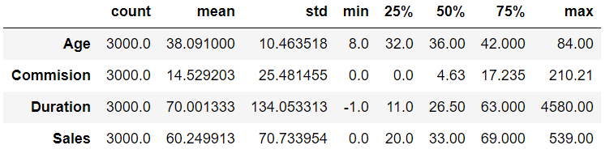Tab 3: Descriptive stats **Initial descriptive analysis**  
 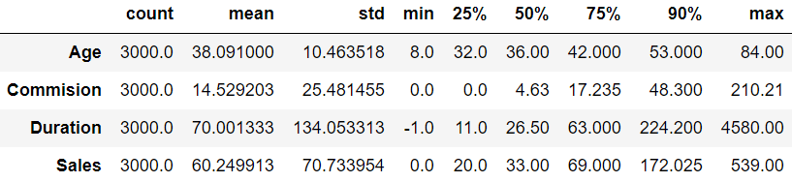  
Tab 4: Initial descriptive analysis

**Observations**Duration has negative value, while it’s not possible, so it must be a wrong entry.

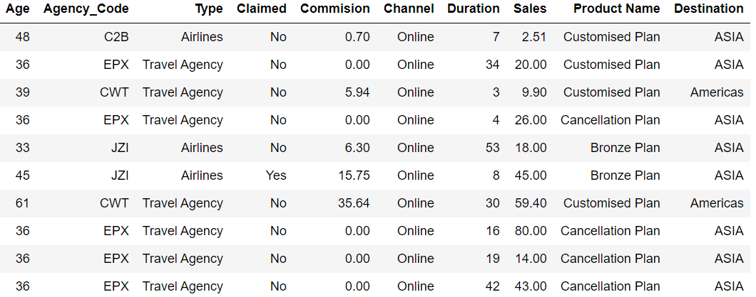For sales and commision (which we think is commission misspelt), the mean and the median vary a lot.

### Agency code EPX has a frequency of 1365.

### The most preferred type seems to be travel agency. Customized plan is the most sought plan by customers

### Asia seems to be most sought-after of all destinations.

### We will further look at the distribution of dataset in the univariate and bivariate analysis.

### Summary of all the variables

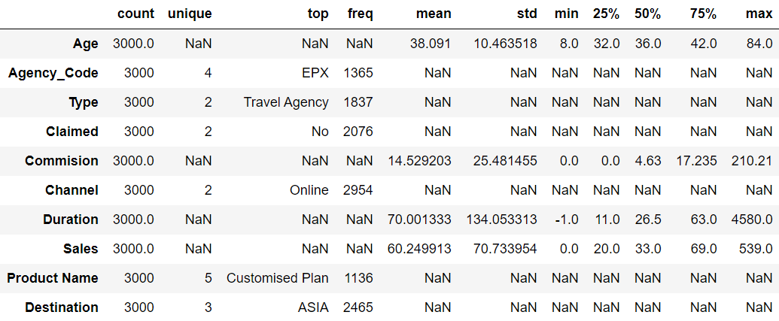**Observation**

Tab 6: Summary of all the variables

For categorial code variables, maximun unique count is 5 (for Product Name)

Tab 4: First 10 rows  
 **First** **10 recordsObservation:** All fine.

### 

Tab 5: Last 10 rows  
 **Last** **10 records  
Observation:** All fine here as well.

### 

### Data dimensions

(3000, 10)

3,000 rows and 10 columns

### Getting unique counts for all the categorical variables

AGENCY_CODE : 4  
JZI 239  
CWT 472  
C2B 924  
EPX 1365  
Name: Agency_Code, dtype: int64  
  
  
TYPE : 2  
Airlines 1163  
Travel Agency 1837  
Name: Type, dtype: int64  
  
CLAIMED : 2  
Yes 924  
No 2076  
Name: Claimed, dtype: int64  
  
CHANNEL : 2  
Offline 46  
Online 2954  
Name: Channel, dtype: int64  
  
PRODUCT NAME : 5  
Gold Plan 109  
Silver Plan 427  
Bronze Plan 650  
Cancellation Plan 678  
Customised Plan 1136  
Name: Product Name, dtype: int64  
  
DESTINATION : 3  
EUROPE 215  
Americas 320  
ASIA 2465  
Name: Destination, dtype: int64

### Check for duplicate data

Number of duplicate rows = 139

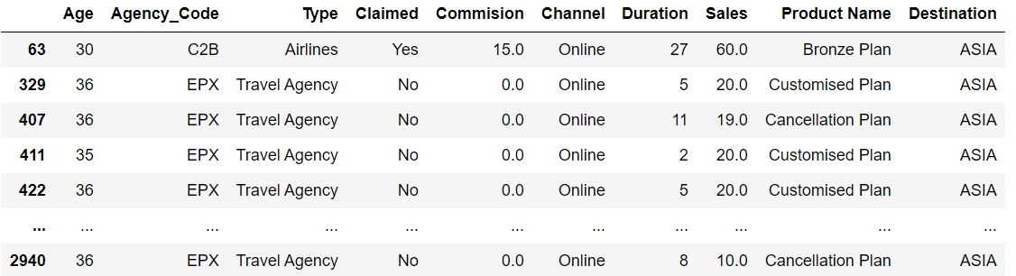

### Tab 6: Duplicated rows

### Not removing duplicates and here's why

Even though 139 records are suggested to be duplicate, these can be of different customers, since there is no customer ID or any unique identifier. So, we choose not to drop these.

## Univariate Analysis

### Age

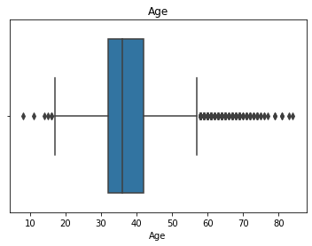Range of values: 76

### Fig 1: Boxplot for age

#Central values

Minimum Age: 8  
Maximum Age: 84  
Mean value: 38.091  
Median value: 36.0  
Standard deviation: 10.463518245377944  
Null values: False

Fig 2: Distribution plot and histogram for age  
  
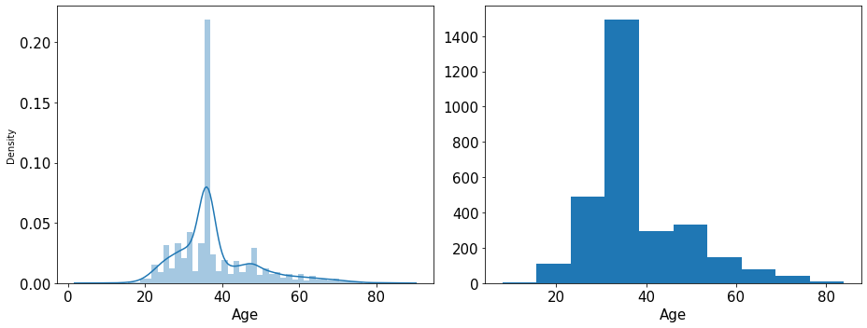#Quartiles  
  
Age - 1st Quartile (Q1) is: 32.0  
Age - 3st Quartile (Q3) is: 42.0  
Interquartile range (IQR) of Age is 10.0

#Outlier detection from Interquartile range (IQR) in original data

Lower outliers in Age: 17.0  
Upper outliers in Age: 57.0

Number of outliers in Age upper: 198  
Number of outliers in Age lower: 6  
% of Outlier in Age upper: 7 %  
% of Outlier in Age lower: 0 %

Interpreting the graphs  
The box plot of the age variable shows  
outliers. Spending is positively  
skewed - 1.149713 The distplot shows  
the distribution of data from 20 to 80.  
In the range of 30 to 40 is where the  
majority of the distribution lies.

## 

## Commission variable

Range of values: 210.21

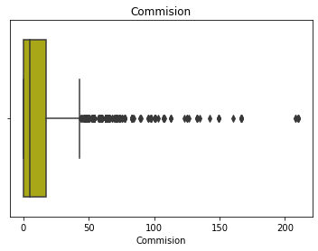

Fig 3: Boxplot for commission

#Central values

Minimum Commission: 0.0  
Maximum Commission: 210.21  
Mean value: 14.529203333333266  
Median value: 4.63  
Standard deviation: 25.48145450662553  
Null values: False

#Quartiles

Commision - 1st Quartile (Q1) is: 0.0  
Commision - 3st Quartile (Q3) is: 17.235  
Interquartile range (IQR) of Commision is 17.235

#Outlier detection from Interquartile range (IQR) in original data

Lower outliers in Commission: -25.8525  
Upper outliers in Commision: 43.0875

Number of outliers in Commission upper : 362  
Number of outliers in Commission lower : 0  
% of Outlier in Commission upper: 12 %  
% of Outlier in Commission lower: 0 %

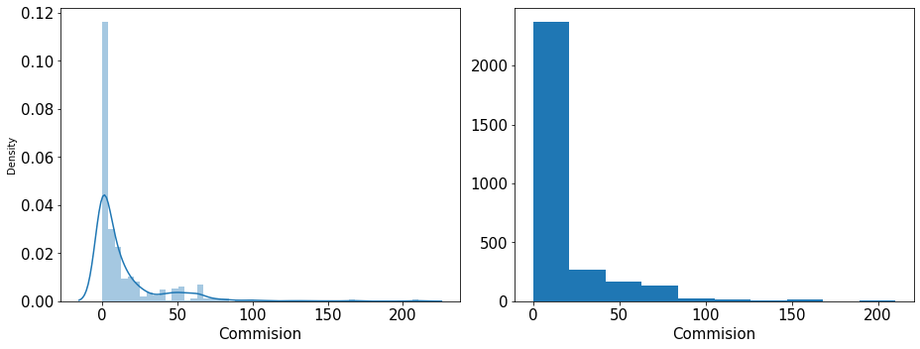Interpreting the graphs

Fig 4: Distribution plot and histogram for  
commission

The boxplot of the commission variable shows outliers. Spending is positively skewed - 3.148858. The distplot shows the distribution of data from 0 to 30.

## Duration

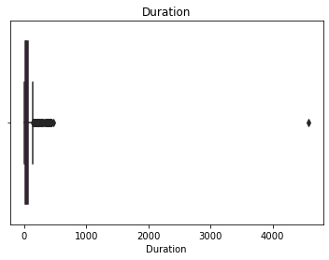Range of values: 4,581

Fig 5: Boxplot for Duration

#Central values   
Minimum Duration: -1  
Maximum Duration: 4580  
Mean value: 70.00133333333333  
Median value: 26.5  
Standard deviation: 134.05331313253495  
Null values: False

# Quartiles  
  
Duration - 1st Quartile (Q1) is: 11.0  
Duration - 3st Quartile (Q3) is: 63.0  
Interquartile range (IQR) of  
Duration is 52.0

#Outlier detection from Interquartile range (IQR) in original data)

Lower outliers in Duration: -67.0  
Upper outliers in Duration: 141.0

Number of outliers in Duration  
upper: 382

Number of outliers in Duration  
lower: 0

Outliers in Duration upper: 13 %  
Outliers in Duration lower: 0 %

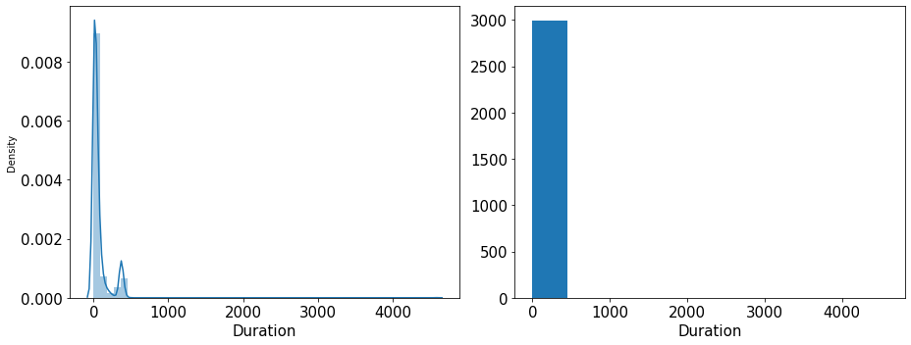Interpreting the graphs

## Fig 6: Distribution plot and histogram for duration

## The box plot of the duration variable shows outliers. Spending is positively skewed - 13.784681 The dist plot shows the distribution of data from 0 to 100

## Sales

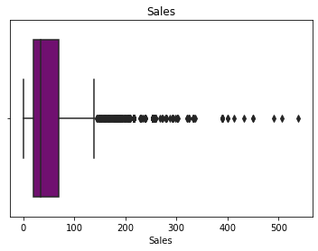Range of values: 539.0

## Fig 7: Boxplot for sales

#Central values   
Minimum Sales: 0.0  
Maximum Sales: 539.0  
Mean value: 60.24991333333344  
Median value: 33.0  
Standard deviation: 70.73395353143047  
Null values: False

#Quartiles  
Sales - 1st Quartile (Q1) is: 20.0  
Sales - 3st Quartile (Q3) is: 69.0  
Interquartile range (IQR) of Sales is 49.0

#Outlier detection from  
Interquartile range (IQR) in  
original data # IQR=Q3-Q1

L_outliers=Q1-1.5*(Q3-Q1)  
U_outliers=Q3+1.5*(Q3-Q1)  
Lower outliers in Sales: -53.5  
Upper outliers in Sales: 142.5

Number of outliers in Sales upper: 353  
Number of outliers in Sales lower: 0  
% of Outlier in Sales upper: 12 %  
% of Outlier in Sales lower: 0 %

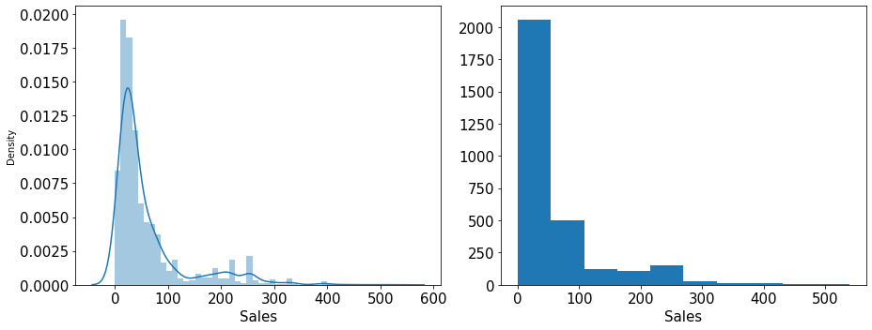Interpreting the graphs

## Fig 8: Distribution plot and histogram for sales

The boxplot of the sales variable shows outliers. Sales is positively skewed - 2.381148. The distplot shows the distribution of data from 0 to 300.

**Observation on outliers**

There are outliers in all the variables but the sales and commission figures can be genuine. Besides, Random Forest and CART can handle the outliers. Outliers are also too many for us to be comfortable removing them without consulting the business. Hence, we will keep the data as it is and treat the outliers for the ANN model to compare the same after all the steps are done.

## Categorical variables

### Agency_Code

## Fig 9: Countplot for agency code

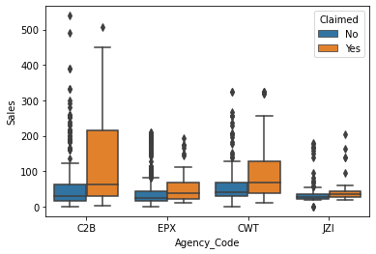# Boxplot

Fig 10: Boxplot for agency code

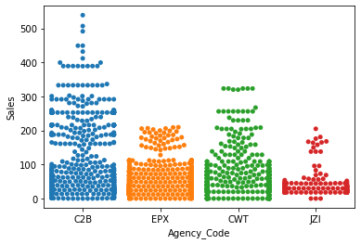# Swarmpot

Fig 11: Swarmplot for agency code

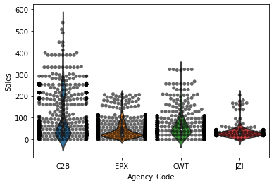# Combined Violin and Swarm plot

Fig 12: Combined swarm-and-violin plot for  
agency code

The distribution of the agency code,  
shows us EPX with maximum frequency.   
The boxplot shows the split of sales for   
different agencies and a comparison of  
their yes and no claims. The boxplot  
shows that C2B has more claims for any   
agency. The bimodal nature of the

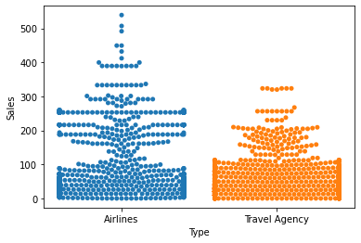distributions is much clearer in the  
swarmplot and their shape can almost be made out. Also, it plots all the data points. However, the thickness of the plotted   
points causes the formation of the strands  
extending out from each swarm, which   
make judging the true shape of the   
distributions difficult, so we combine it   
with the violin plot, which also tells us the density.

### Type

Fig 13: Countplot for type

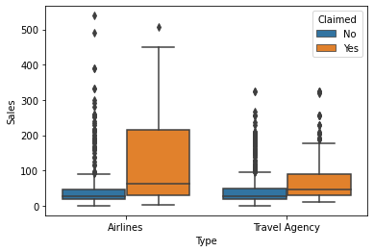

Fig 14: Boxplot for type

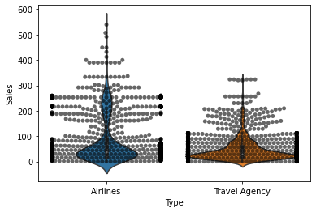Fig 15: Swarmplot for type

Fig 16: Combined swarm-and-violin plot for type

Even though fewer in numbers, the airlines seem to be outcompeting the travel agencies in sales, but they also have more claims. Travel agencies have more density, a fatter bulge at the bottom. Airlines seem to be making money at the top.

### Channel

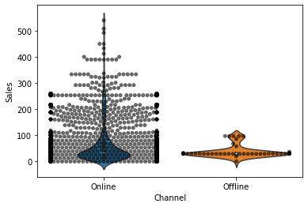

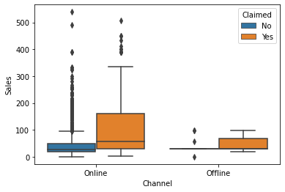Fig 17: Countplot for channel

Fig 18: Boxplot for channel

By a huge majority, the customers have chosen the online over the offline channel for booking, but the online channel also has more claims. It shows how agencies have improved their booking portals and made it easier for the customer.

Fig 19: Swarmplot for channel

Fig 20: Swarm-and-violin plot for channel

### Product Name

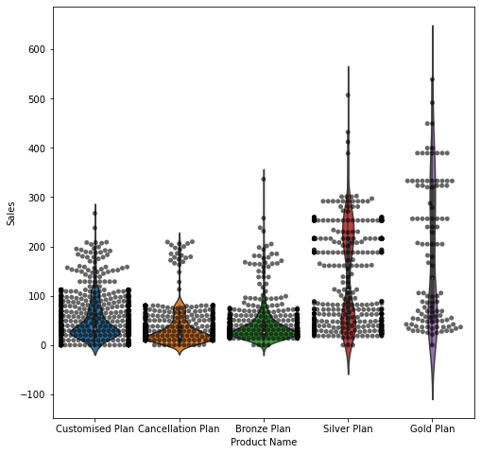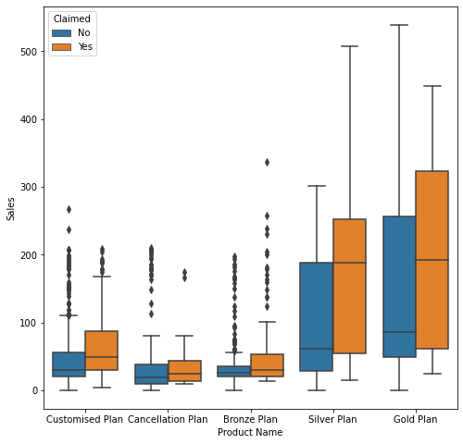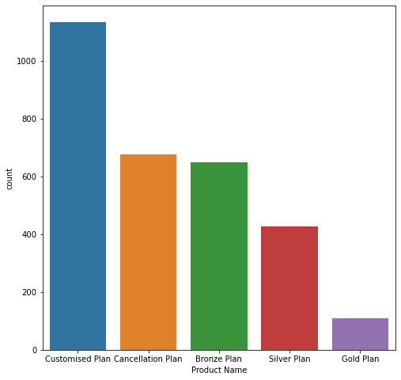

Fig 21, 22, 23, 24: Countplot, boxplot, swarmplot, and swarm-and-violin plot for channel

Customized plan seems to be the most liked by the customers and the most rewarding for the agencies, while both yes and no claims are the highest for the   
  
  
  
gold plan. This plan has also accounted for most sales, keeping the cash registers ringing.

### Destination

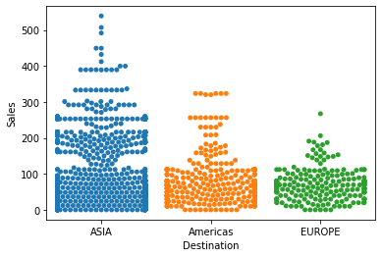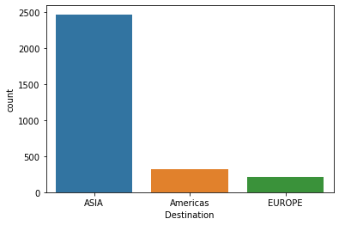

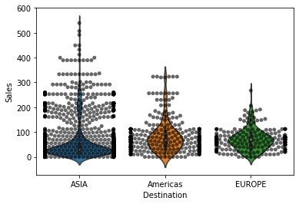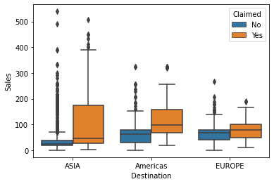

Most popular destination? Not developed Americas or Europe but a culturally richer and tropically warmer Asia, but it also accounts for most claims. Maybe the destination is good but the customer experience is not or maybe one-size-fit-all packages don’t work. A local awareness programme can help encourage tour and travel.

Fig 25, 26, 27, 28: Countplot, boxplot, swarmplot, and swarm-and-violin plot for destination

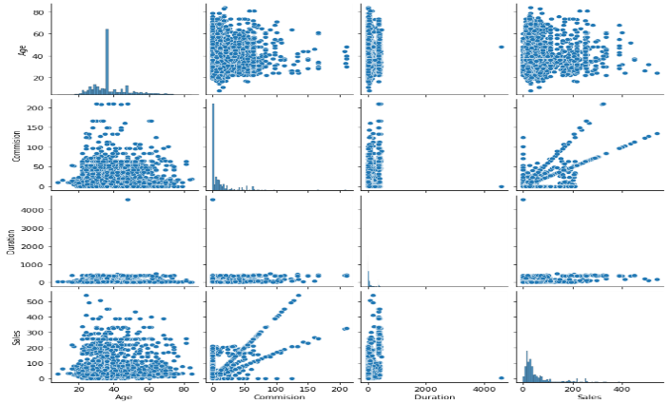

**Checking pairwise distribution of the continuous variables**

Not much of multi collinearity observed No negative correlation. Only positive correlations seen.

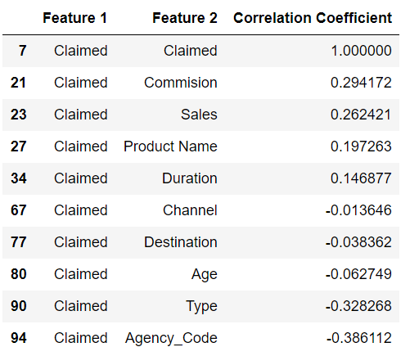

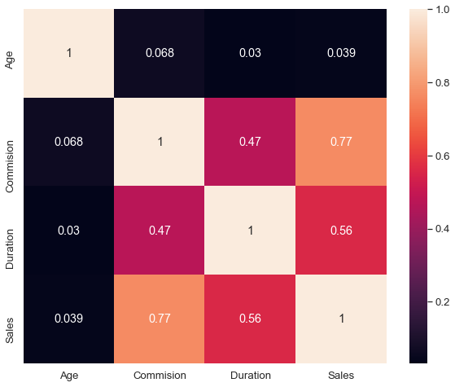

## Figs 29 and 30: Pairplot and heatmap

## Checking for Correlations

A heatmap with only continuous variables and checking correlation coefficients  
against ‘claimed’ shows that it correlates  
the most with commission and sales.

## Converting all objects to categorical codes

feature: Agency_Code  
['C2B', 'EPX', 'CWT', 'JZI']  
Categories (4, object): ['C2B', 'CWT', 'EPX', 'JZI']  
[0 2 1 3]  
  
  
feature: Type  
['Airlines', 'Travel Agency']  
Categories (2, object): ['Airlines', 'Travel Agency']  
[0 1]  
  
  
feature: Claimed  
['No', 'Yes']  
Categories (2, object): ['No', 'Yes']  
[0 1]  
  
  
feature: Channel  
['Online', 'Offline']  
Categories (2, object): ['Offline', 'Online']  
[1 0]  
  
  
feature: Product Name  
['Customised Plan', 'Cancellation Plan', 'Bronze Plan', 'Silver Plan', 'Gold Plan']  
Categories (5, object): ['Bronze Plan', 'Cancellation Plan', 'Customised Plan', 'Gold Plan', 'Silver Plan']  
[2 1 0 4 3]  
  
  
feature: Destination  
['ASIA', 'Americas', 'EUROPE']  
Categories (3, object): ['ASIA', 'Americas', 'EUROPE']  
[0 1 2]

# Column Dtype   
--- ------ ------   
 0 Age int64   
 1 Agency_Code int8   
 2 Type int8   
 3 Claimed int8   
 4 Commision float64  
 5 Channel int8   
 6 Duration int64   
 7 Sales float64  
 8 Product Name int8   
 9 Destination int8

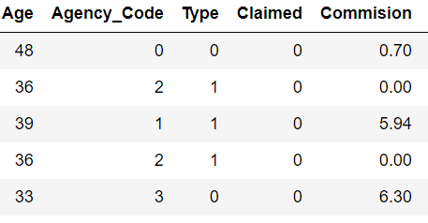

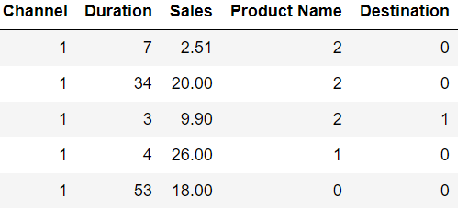

## Tab 7: Data converted and coded

**Observation**

Data types converted and coded successfully

## Proportion of 1s and 0s

0 0.692  
1 0.308

Seems a balanced dataset

**2.2 Data Split: Split the data into test  
and train, build classification model  
CART, Random Forest, Artificial  
Neural Network**

## Extracting the target column into separate vectors for training set and test set

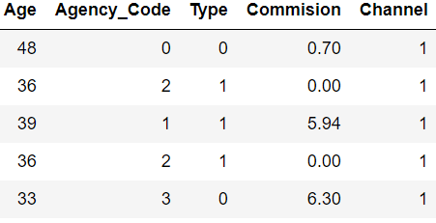

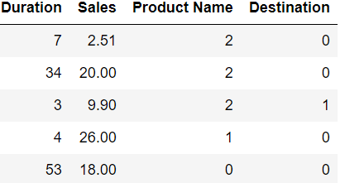

## Tab 8: The dataset after extracting target column ‘claimed’

## # Prior to scaling

## Fig 31: The dataset before scaling

# Scaling the attributes.  
  
The data has a few variables on different  
scales, so it become necessary to scale the data. We used z-scaling, because the  
variance between the columns is more or less the same.

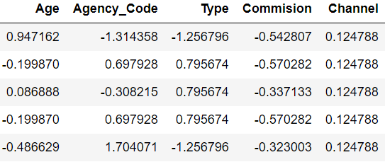

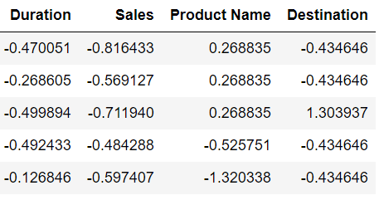

## Tab 9: The scaled dataset

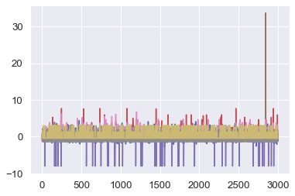# After scaling

## Fig 32: The dataset after scaling

## Splitting data into training and test set and checking their dimensions

X_train (2100, 9)  
X_test (900, 9)  
train_labels (2100,)  
test_labels (900,)

## Building a Decision Tree Classifier

Parameters passed

'criterion': ['gini']  
'max_depth': [10,20,30,50]  
'min_samples_leaf': [50,100,150]   
'min_samples_split': [150,300,450]

Output:

{'criterion': 'gini', 'max_depth': 10, 'min_samples_leaf': 50, 'min_samples_split': 450}

Best grid:

DecisionTreeClassifier  
(max_depth=10, min_samples_leaf=50, min_samples_split=450,  
random_state=1)

Second parameter set  
'criterion': ['gini'],  
'max_depth': [3, 5, 7, 10,12],  
'min_samples_leaf: [20,30,40,50,60]   
'min_samples_split': [150,300,450]

Output:

{'criterion': 'gini', 'max_depth': 5, 'min_samples_leaf': 20, 'min_samples_split': 150}

Best grid:

DecisionTreeClassifier

(max_depth=5, min_samples_leaf=20, min_samples_split=150,  
random_state=1)

Third parameter set  
'criterion': ['gini'],  
'max_depth': [3.5,4.0,4.5, 5.0,5.5]   
'min_samples_leaf': [40, 42, 44,46,48,50,52,54],   
'min_samples_split': [250, 270, 280, 290, 300,310]  
  
Output:

{'criterion': 'gini', 'max_depth': 3.5, 'min_samples_leaf': 44, 'min_samples_split': 250}

Best grid:

DecisionTreeClassifier(max_depth=3.5, min_samples_leaf=44,  
min_samples_split=250, random_state=1)

Fourth parameter set  
'criterion': ['gini'],  
'max_depth': [4.85, 4.90,4.95, 5.0,5.05,5.10,5.15],  
'min_samples_leaf': [40, 41,

42, 43, 44],   
min_samples_split: [150, 175, 200, 210, 220, 230, 240, 250, 260, 270]   
  
Output:

{'criterion': 'gini', 'max_depth': 4.85, 'min_samples_leaf': 44, 'min_samples_split': 260}

Best grid:

DecisionTreeClassifier(max_depth=4.85, min_samples_leaf=44,  
min_samples_split=260,  
random_state=1)

## Fig 33: The decision tree Generating Tree

A regularised (pruned) tree

The splitting criterion is agency code.  
A total of 2,100 agencies were divided  
647: 1453 between sales and product  
name, respectively. The sales were  
further split 254 and 393, while product  
name was further split 1199 and 254. Agency code, sales, and product name are the most important features or variables,  
an analysis based on the following scores.

## Variable Importance – DTCL

Imp  
Agency_Code 0.634112  
Sales 0.220899  
Product Name 0.086632  
Commision 0.021881  
Age 0.019940  
Duration 0.016536  
Type 0.000000  
Channel 0.000000  
Destination 0.000000

## Predicting on Training and Test dataset

## Getting the Predicted Classes and Probabilities

0 1  
0 0.697947 0.302053  
1 0.979452 0.020548  
2 0.921171 0.078829  
3 0.510417 0.489583  
4 0.921171 0.078829

These are the fractions of trees voting  
either class. The class probability of a  
single tree is the fraction of samples of the same class in a leaf. This tree predicts 2 to 30% chances of filing a claim. For  
example, 175 agencies among 304 with  
short-duration tours out of 574 with low  
sales are predicted to get requests for  
claims.

# Building a Random Forest Classifier

Parameters set

'max_depth': [5,10,15],  
'max_features': [4,5,6,7],  
'min_samples_leaf': [10,50,70],  
'min_samples_split': [30,50,70],  
'n_estimators': [200, 250,300]  
   
Output:

{'max_depth': [5, 10, 15],  
'max_features': [4, 5, 6, 7],  
'min_samples_leaf': [10, 50, 70],  
'min_samples_split': [30, 50, 70],  
'n_estimators': [200, 250, 300]})

best parameters

{'max_depth': 5,  
 'max_features': 5,  
 'min_samples_leaf': 10,  
 'min_samples_split': 50,  
 'n_estimators': 250}

Best grid

RandomForestClassifier  
(max_depth=5, max_features=5,  
min_samples_leaf=10,  
min_samples_split=50,  
n_estimators=250, random_state=1)

Second parameters set  
'max_depth': [4,5,6],  
'max_features': [2,3,4,5],  
'min_samples_leaf': [8,9,11,15],  
'min_samples_split': [46,50,55],   
'n_estimators': [290,350,400]

Output:

{'max_depth': [4, 5, 6],  
'max_features': [2, 3, 4, 5],  
'min_samples_leaf': [8, 9, 11, 15],'min_samples_split': [46, 50, 55],  
'n_estimators': [290, 350, 400]})

best parameters

{'max_depth': 6,  
 'max_features': 3,  
 'min_samples_leaf': 8,  
 'min_samples_split': 46,  
 'n_estimators': 350}

Best grid

RandomForestClassifier  
(max_depth=6, max_features=3,  
min_samples_leaf=8,  
min_samples_split=46,  
n_estimators=350, random_state=1)

### Predicting the Training and Testing data

### Getting the Predicted Classes and Probabilities

0 1  
0 0.778010 0.221990  
1 0.971910 0.028090  
2 0.904401 0.095599  
3 0.651398 0.348602  
4 0.868406 0.131594

### Variable Importance via RF

Imp  
Agency_Code 0.276015  
Product Name 0.235583  
Sales 0.152733  
Commision 0.135997  
Duration 0.077475  
Type 0.071019  
Age 0.039503  
Destination 0.008971  
Channel 0.002705

Random forest also shows the same  
three variables (Agency_Code,  
Product Name, and Sales to be most  
important features, in that order, in  
deciding if some customer will file a claim or not)

## Building a Neural Network Classifier

Parameters set  
'hidden_layer_sizes': [50,100,200],  
'max_iter': [2500,3000,4000],  
'solver': ['adam'],  
'tol': [0.01],

Output:

'hidden_layer_sizes': [50, 100, 20]  
'max_iter': [2500, 3000, 4000]  
'solver': ['adam']  
'tol': [0.01]})

**TPR**

Best parameters

{'hidden_layer_sizes': 200,  
'max_iter': 2500, 'solver': 'adam', 'tol': 0.01}

Best grid

MLPClassifier  
(hidden_layer_sizes=200, max_iter=2500, random_state=1, tol=0.01)

**FPR**

### Predicting the Training and Testing data

### Getting the predicted classes and probabilities

0 1  
0 0.822676 0.177324  
1 0.933407 0.066593  
2 0.918772 0.081228  
3 0.688933 0.311067  
4 0.913425 0.086575

The Artificial Neural Network predicts  
6 to 17% chance of being asked for claim.

# 2.3 Performance Metrics: Check the performance of Predictions on Train and Test sets using Accuracy, Confusion Matrix, Plot ROC curve and get ROC_AUC score for each model

## CART - AUC and ROC for the training data

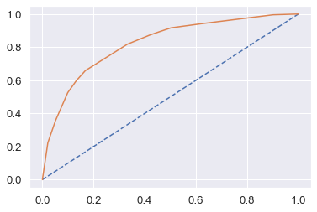AUC: 0.823  
This is area under the curve.

Fig 34: Receiver operating characteristic (ROC) curve for CART training data, plotting true positive rate (TPR) against false positive rate (FPR)

## CART -AUC and ROC for the test data

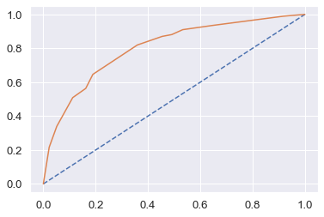AUC: 0.801

Fig 35: Receiver operating characteristic (ROC) curve for CART test data

## CART Confusion Matrix and Classification Report for the training data

Fig 36: Confusion matrix for CART training data

#Train Data Accuracy  
0.7852380952380953

Classification report:-

precision recall f1-score support  
  
 0 0.81 0.90 0.85 1453  
 1 0.70 0.53 0.60 647  
  
 accuracy 0.79 2100  
 macro avg 0.76 0.71 0.73 2100  
weighted avg 0.78 0.79 0.78 2100

cart_train_precision 0.7  
cart_train_recall 0.53  
cart_train_f1 0.6

### Train Data

AUC: 82%  
Accuracy: 79%  
Precision: 70%  
f1-Score: 60%

Training and Test set results are almost similar, and with the overall measures high, this is a good model. Agency_Code is the most important variable for predicting claim.

## Cart Conclusion

## CART Confusion Matrix and Classification Report for the testing data

Fig 37: Confusion matrix for CART test data

#Test Data Accuracy  
0.7711111111111111

Classification report:-

precision recall f1-score support  
  
 0 0.80 0.89 0.84 623  
 1 0.67 0.51 0.58 277  
  
 accuracy 0.77 900  
 macro avg 0.74 0.70 0.71 900  
weighted avg 0.76 0.77 0.76 900

cart_test_precision 0.67  
cart_test_recall 0.51  
cart_test_f1 0.58

### Test Data

AUC: 80%  
Accuracy: 77%  
Precision: 80%  
f1-Score: 84%

## RF Model Performance Evaluation on Training data

Fig 38: Confusion matrix for RF training data

RF training accuracy score  
0.8042857142857143

Classification report:-

precision recall f1-score support  
  
 0 0.84 0.89 0.86 1453  
 1 0.72 0.61 0.66 647  
  
 accuracy 0.80 2100  
 macro avg 0.78 0.75 0.76 2100  
weighted avg 0.80 0.80 0.80 2100

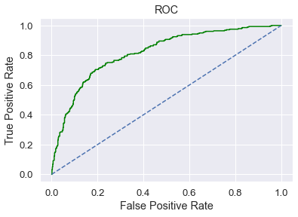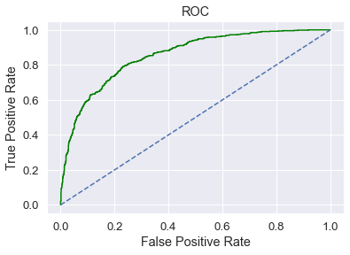rf_train_precision 0.72  
rf_train_recall 0.61  
rf_train_f1 0.66  
Fig 39: ROC curve for RF training data  
Area under Curve is   
0.8563713512840778

## RF Model Performance Evaluation on Test data

Fig 40: Confusion matrix for RF test data

RF test accuracy score  
0.7844444444444445

Classification report:-

precision recall f1-score support  
  
 0 0.82 0.88 0.85 623  
 1 0.68 0.56 0.62 277  
  
 accuracy 0.78 900  
 macro avg 0.75 0.72 0.73 900  
weighted avg 0.78 0.78 0.78 900  
  
rf_test_precision 0.68  
rf_test_recall 0.56  
rf_test_f1 0.62

Fig 41: ROC curve for RF test data  
Area under Curve is  
0.8181994657271499

### Random Forest Conclusion

### Train Data

AUC: 86%  
Accuracy: 80%  
Precision: 72%  
f1-Score: 66%

### Test Data

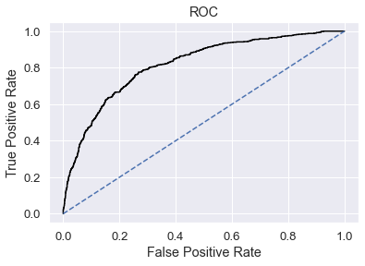AUC: 82%  
Accuracy: 78%  
Precision: 68%  
f1-Score: 62

Training and Test set results are almost similar, and with the overall measures high, this is also a good model.

Agency_Code is again the most important variable for predicting claim.

## NN Model Performance Evaluation on Training data

Fig 42: Confusion matrix for ANN training data

NN training data accuracy score  
0.7761904761904762

Classification report:-

precision recall f1-score support  
  
 0 0.80 0.89 0.85 1453  
 1 0.68 0.51 0.59 647  
  
 accuracy 0.78 2100  
 macro avg 0.74 0.70 0.72 2100  
weighted avg 0.77 0.78 0.77 2100

nn_train_precision 0.68  
nn_train_recall 0.51  
nn_train_f1 0.59

Fig 43: ROC curve for ANN training data  
  
Area under Curve is  
0.8166831721609928

## NN Model Performance Evaluation on Test data

Fig 44: Confusion matrix for ANN test data

NN test accuracy score  
0.7688888888888888

Classification report:-

precision recall f1-score support  
  
 0 0.80 0.89 0.84 623  
 1 0.67 0.50 0.57 277  
  
 accuracy 0.77 900  
 macro avg 0.73 0.69 0.71 900  
weighted avg 0.76 0.77 0.76 900

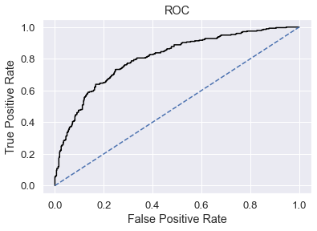nn_test_precision 0.67  
nn_test_recall 0.5  
nn_test_f1 0.57

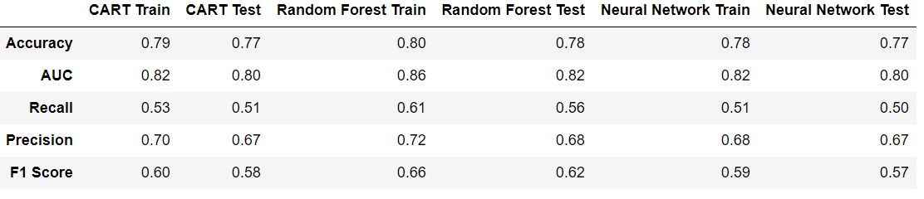Fig 45: ROC curve for ANN test data  
  
  
Area under Curve is  
0.8044225275393896

### Neural Network Conclusion

### Train Data

AUC: 82%  
Accuracy: 78%  
Precision: 68%  
f1-Score: 59

### Test Data

AUC: 80%  
Accuracy: 77%  
Precision: 67%  
f1-Score: 57%

## Neural network conclusion

Training and test set results are almost similar, and with the overall measures high, this as well is a good model. Neural network is a 'black box' method that doesn't give you the most important variables. One doesn't know what happens in the hidden layers.

# 

# 2.4 Final Model: Compare all the model and write an inference which model is best/optimized.

Tab 10: Comparison of the training and test data of three different models

# 

### ROC Curve for the training data for three models

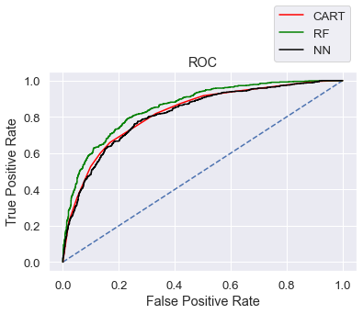

## ROC Curve for the test data for three models

# Conclusion

For predicting claim, we select the Random Forest model, as it has better accuracy, precsion, recall, and f1 score than the CART and Neural Network models.

# 2.5 Inference: Based on these predictions, what are the business insights and recommendations

The data shows that 90% of insurance is done via the online channel.

Streamlining online experiences benefitted customers, leading to an increase in conversions, which raised profits.

Almost all the offline business has a 'claim' associated. We must find out why.

Agency JZI must train its resources to pick up sales, since the agency is scraping the bottom of the business. It can run a promotional marketing campaign or evaluate if it needs to tie up with another agency.

The RF model gives us 80% accuracy. Based on this claim data pattern, the agencies can cross sell insurance to the people who book airline tickets or holiday plans.

More sales happen via airlines than the agency. The claims as well are processed more at the airlines. We may have to do a deeper investigation of the workflow.

Key performance indicators (KPIs) of the insurance claims are:- Reduce claims cycle time. Increase customer satisfaction. Combat fraud. Optimize claims recovery. Reduce claim handling costs.

Insights gained from data and machine-learning-powered analytics can help the agencies insure more people, extend their products, and discover new risk-transfer solutions in areas such as non-damage business interruption and reputational damage.

We recommended collecting more  
real-time, unstructured, and previous data, if possible, to be able to also study the impact of day of the incident, time, age group on claims and associate it with external information such as location, behavior patterns, weather information, and the type of airline and vehicle.  
 **Last look at the target variable and some other features**



[This Photo](http://www.finsmes.com/2017/06/why-every-travel-agency-needs-a-custom-website-design.html) by Unknown Author is licensed under [CC BY-NC-ND](https://creativecommons.org/licenses/by-nc-nd/3.0/)

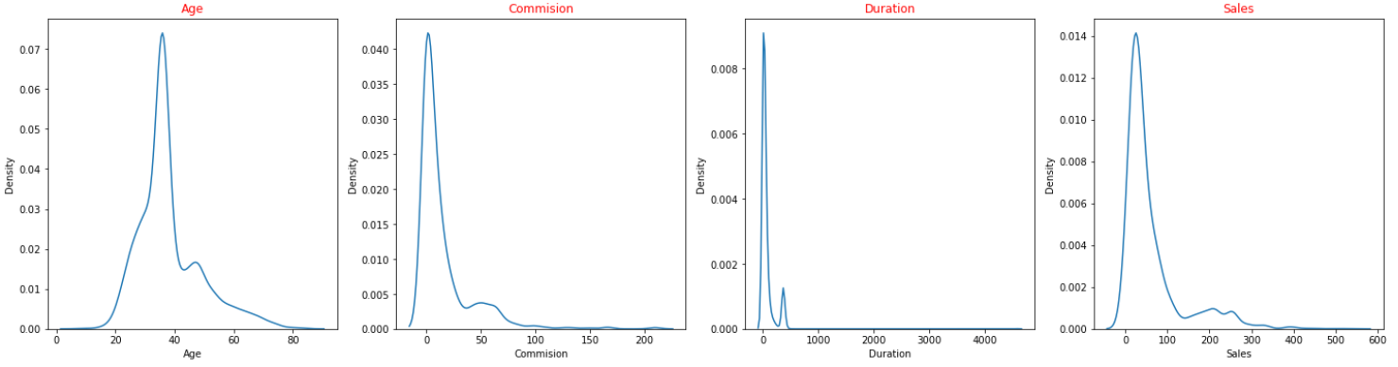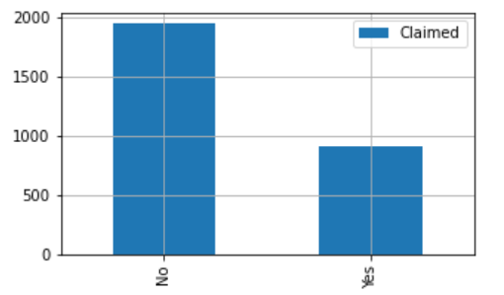**Claims**

**Inference:**  
The volume of claims is worrisome  
indeed for the tour agencies.



[This Photo](https://www.freepngimg.com/png/30765-travel-photos) by Unknown Author is licensed under [CC BY-NC](https://creativecommons.org/licenses/by-nc/3.0/)

20 to 40 is the age of travelling and that’s where most customers are.  
Low commission is on the higher side.

Short trips make tallest curves.

Sales between 0 and100 occur the most.

Happy travelling